ELECTRICAL
SAFETY RECALL

Clipsal 230DRAQ, 230DRAQTP, 230DRAVL, 230DRAT Meter Boxes

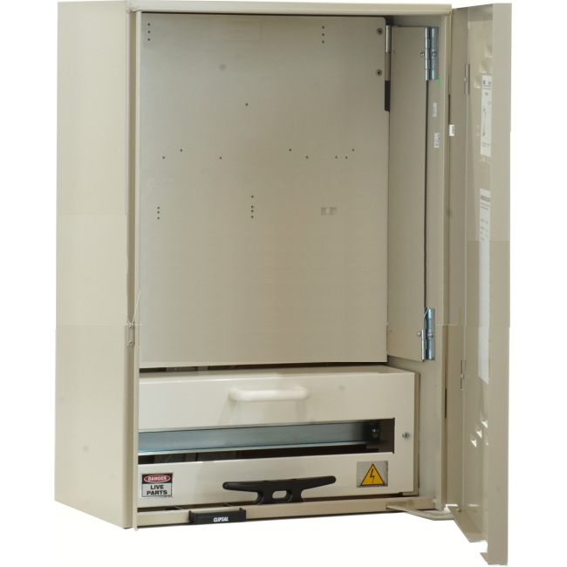

Affected product was sold to and available for purchase from electrical wholesalers between 18th April 2016 and 17 August 2016 (inclusive) and can be identified by Serial # XXXX-2016-10-XXXXX to XXXX-2016-33-XXXXX (inclusive)

Defect The conductive parts of the enclosure may not be effectively earthed, as the earth cable supplied in the meter boxes was not manufactured to specifications and is not compliant to standards.

Hazard This could result in a potential electric shock if a live wire were to come into contact with the enclosure.

What to do
Electrical contractors/wholesalers
1. Check your stock for affected product (by serial number)
2. Review sales and installations that may have used affected products.
3. Where affected products have been identified, please return them immediately to your place of purchase. If a product is already installed and cannot be returned, then contact us for further details about rectification requirements.
Consumers
If consumers have had a Clipsal meter box installed at their home or premises from 18 April 2016 they may have an affected product. Contact Clipsal on 1300 369 233 for further instructions.
For further information
Please direct all calls and any queries concerning this recall to

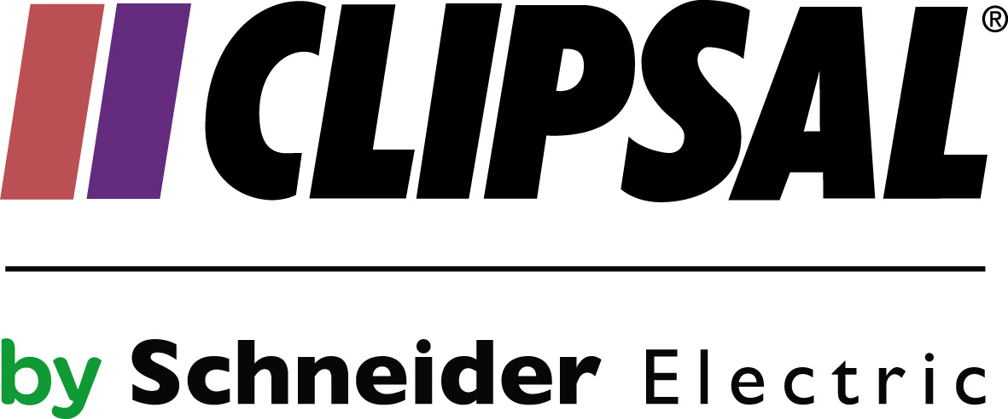

Website: www.clipsal.com/230DRAVL_Q_QTP_T_recall Phone: 1300 369 233

See www.recalls.gov.au for Australian product recall information

