###### ELECTRICAL SAFETY RECALL

**Heos 1 Go Pack by Denon Rechargeable Battery**

D. & M. Holdings Pty. Ltd. and QualiFi Pty Ltd are conducting a recall of the Heos 1 Go Pack by Denon Rechargeable Battery.

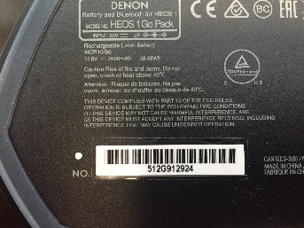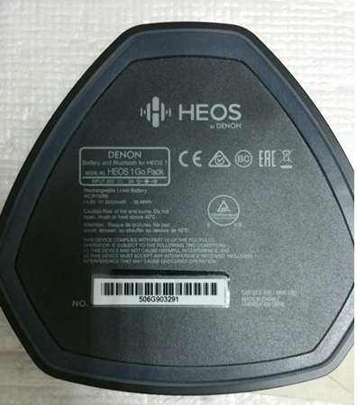

**Identification:**

All serial numbers beginning with 5xxGxxxxxx and serial numbers between 601G913517 to 601G914004

The serial number is located on the bottom of the base of the battery.

**Where the product was sold:**

The product was sold at various electronic retailers from 19 May 2015 to 18 July 2016.

**Defect:**

The battery cells in the rechargeable battery pack may combust.

**Hazard:**

If the battery cells combust, the rechargeable battery may pose a fire safety hazard.

**Action Required:**

Consumers should immediately discontinue use of the rechargeable battery pack and consumers should contact Qualifi Pty Ltd for instructions to replace the product.

**For further information**

Please direct all calls and any queries concerning this recall to QualiFi Pty Ltd on 03 8543 1166 or support@heos.com.au or visit www.qualifi.com.au

See [www.recalls.gov.au](http://www.recalls.gov.au) for Australian product recall information