

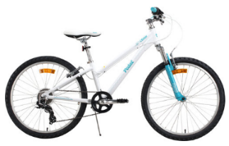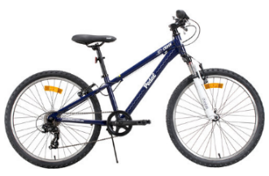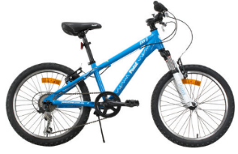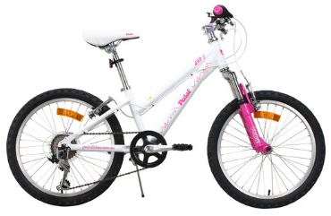

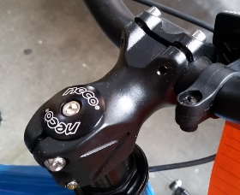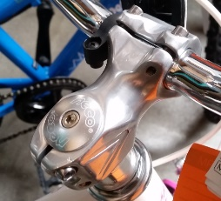

**Pedal Zap and Pedal Crush** bicycles sold nation-wide between May 2016 and February 2017

**Defect** In some circumstances, the stem may crack and fracture under extreme forces whilst riding

**Hazard** If the defect occurs whilst the bicycle is in use, serious injury or death can occur

**What to do** Consumers should stop using the bicycle immediately and contact their local 99 Bikes retailer to have a new stem fitted.

**Contact details** Contact 99 Bikes on 1300 974 754 or go to [www.99bikes.com.au](http://www.99bikes.com.au)