

**FOOD RECALL**

**See www.foodstandards.gov.au/recalls**

**for Australian food recall information**

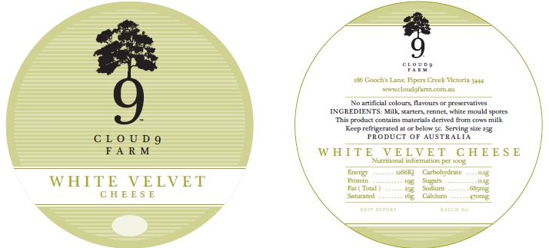

White Velvet Cheese, 150 to 250g

Best Before 25/10/16

Cloud 9 Farm is conducting a recall of the above product. The product has been available for sale at Cloud 9 Farm in VIC.

Problem: The recall is due to microbial (*E.coli*) contamination

Food safety hazard: Food products contaminated with *E.coli* may cause illness if consumed.

What to do: Any consumers concerned about their health should seek medical advice and should return the products to the place of purchase for a full refund.

For further information please contact:

Cloud 9 Farm

0419550378

www.cloud9farm.com.au

**See www.foodstandards.gov.au/recalls**

**for Australian food recall information**