

Product Safety Recall

Crib Mates 2 Pack Pacifier

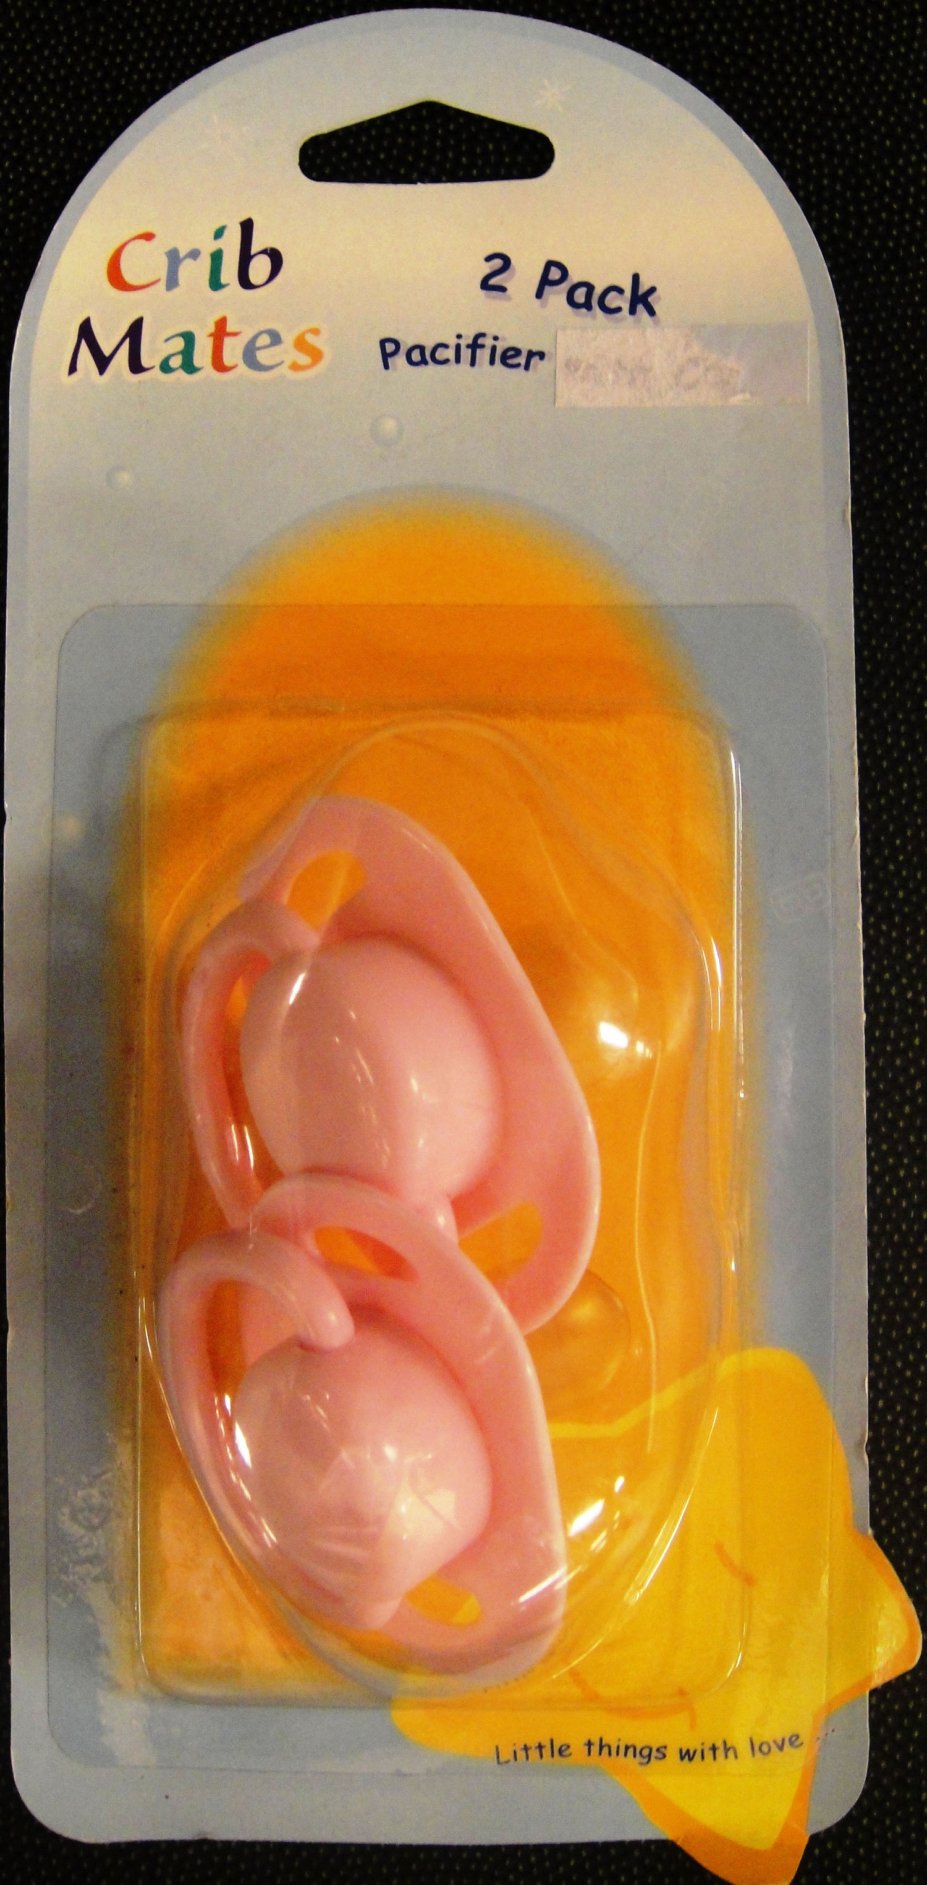
On the advice of the NSW Office of Fair Trading, Super Low Variety is conducting a voluntary recall of the Crib Mates 2 Pack Pacifier.

The pacifier does not comply with the mandatory requirements of the Australian standard. Of particular concern is the teat on the Crib Mates 2 Pack Pacifier can detach and create a choking hazard.

The dummy was sold at this store between June 2008 and June 2009. Consumers should cease using this dummy immediately and destroy or return to this store to receive a full refund.

PRODUCT RECALL

See www.recalls.gov.au for
Australian Product Recall Information

