**PATIENT INFORMATION LETTER**

Wednesday 7th September 2016

**Important safety information for diabetes patients in possession of a GlucaGen® HypoKit**

Novo Nordisk Pharmaceuticals Pty Ltd is recalling 4 batches of GlucaGen® HypoKit in Australia. The GlucaGen® HypoKit is indicated for the ‘treatment of severe hypoglycaemic reactions which may occur in the management of diabetic patients receiving insulin or oral hypoglycaemic agents’.

Novo Nordisk conducted an investigation showing a small number of needles (0.006 %) were detached from the pre-filled syringe supplied in certain batches of the GlucaGen® HypoKit. To protect patient safety, Novo Nordisk is recalling all products in the affected batches from wholesalers, pharmacies and patients in Australia.

The recalled GlucaGen® HypoKit batch numbers and expiry dates are:

|  |  |
| --- | --- |
| **Batch no.** | **Expiry date** |
| FS6X465 | 31-Aug-2017 |
| FS6X536 | 31-Aug-2017 |
| FS6X715 | 31-Aug-2017 |
| FS6X891 | 31-Aug-2017 |

The batch numbers are printed on the GlucaGen® HypoKit as indicated below in the red box.

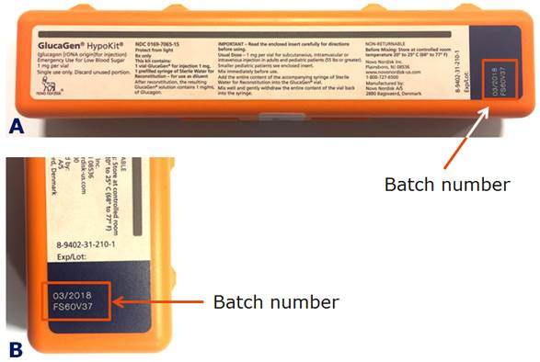

**Figure 1.** A) GlucaGen® HypoKit where the batch number is found in the red box, B) close-up of the batch number

**What to do if you are in possession of a GlucaGen® HypoKit with one of the above-mentioned batch numbers:**

* Return your GlucaGen® HypoKit product with the above-mentioned batch numbers to your pharmacy. You will be given a free replacement GlucaGen® HypoKit either immediately (if pharmacy stock is present) or within a few days (if pharmacy needs to await re-supply). If you do not receive a replacement immediately, retain your GlucaGen® HypoKit until the replacement can be provided, as the likelihood of a detached needle is very low.

**GlucaGen® HypoKit is to be used for episodes of severe hypoglycaemia (low blood sugar) when you have become unconscious or are unable to ingest a source of sugar. It is therefore important that you have a functioning GlucaGen® HypoKit that can be used effectively. Please check the batch number on your GlucaGen® HypoKit and take action as recommended in this communication.**

Importantly, if you are in possession of a GlucaGen® HypoKit product with a batch number **NOT** mentioned above there is no concern and you can be confident that the product will work as prescribed.

If you have any questions regarding this recall, please contact NovoCare® Customer Care Centre on 1800 668 626 for further information.

This action has been undertaken following consultation with the Therapeutic Goods Administration (TGA).

We sincerely regret the inconvenience caused by this action and assure you that Novo Nordisk takes this very seriously and has a rigorous quality assurance philosophy.

Yours sincerely,



Michala Fischer-Hansen

**Managing Director**

**Novo Nordisk Australia & New Zealand**

**Further information:**

NovoCare® Customer Care Centre

Phone: 1800 668 626

Email: [aunrccc@novonordisk.com](mailto:aunrccc@novonordisk.com)

[www.novonordisk.com.au](http://www.novonordisk.co.nz)