$10 Target two-way zip baby coveralls.
Safety recall effective 3/9/18.
Included designs:

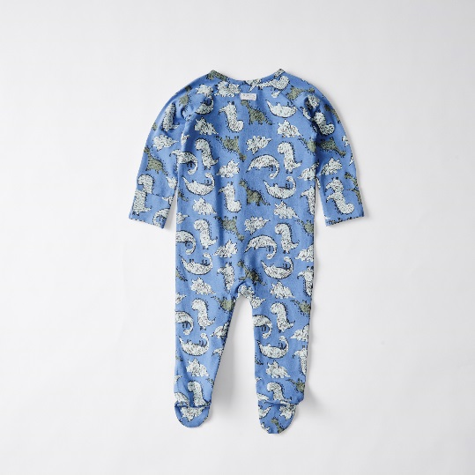
PR 60852724 - DINO BLUE COVERALL
60852892 - Newborn
60852908 - 0-3 months
60852915 - 3-6 months
60852922 - 6-12 months
60852939 - 12-18 months

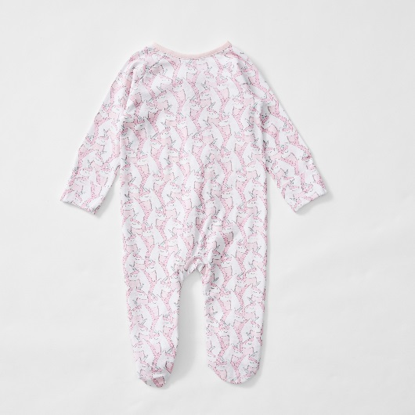

PR 60852786 – UNICORN PINK COVERALL
60853059 - Newborn
60853066 - 0-3 months
60853073 - 3-6 months
60853080 - 6-12 months
60853097 - 12-18 months

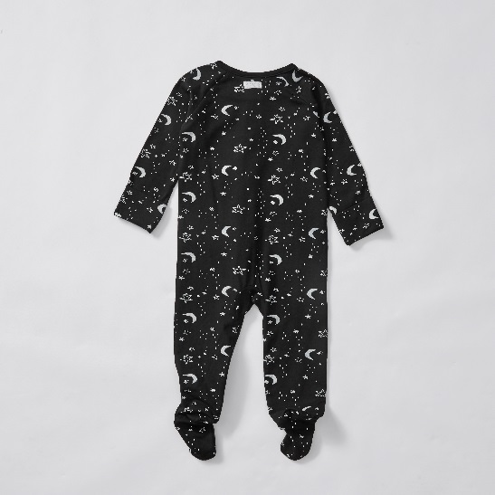

PR 60852779 - MOON BLACK COVERALL
60853295 - Newborn
60853301 - 0-3 months
60853318 - 3-6 months
60853325 - 6-12 months
60853332 - 12-18 months

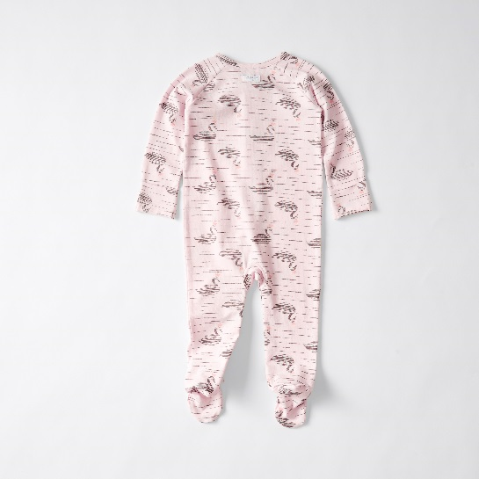

PR 60852731 - SWAN PINK COVERALL
60852977 - Newborn
60852984 - 0-3 months
60852991 - 3-6 months
60853004 - 6-12 months
60853011 - 12-18 months

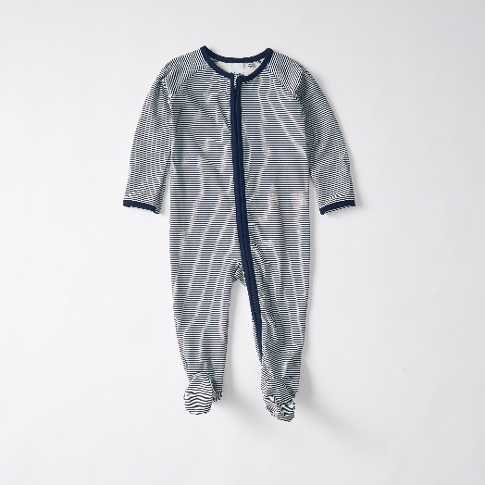

PR 60852762 – STRIPE NAVY COVERALL
60853219 - Newborn
60853226 - 0-3 months
60853233 - 3-6 months
60853240 - 6-12 months
60853257 - 12-18 months

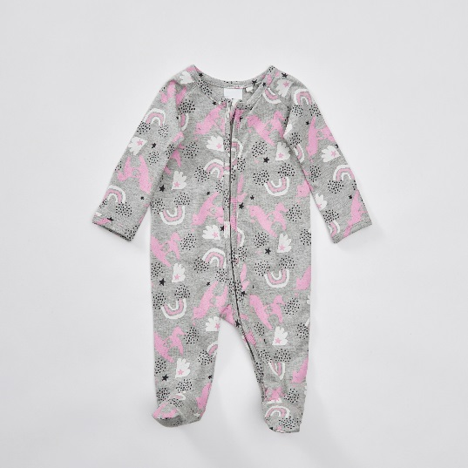

PR 60852755 – PONY GREY COVERALL
60853134 - Newborn
60853141 - 0-3 months
60853158 - 3-6 months
60853165 - 6-12 months
60853172 - 12-18 months

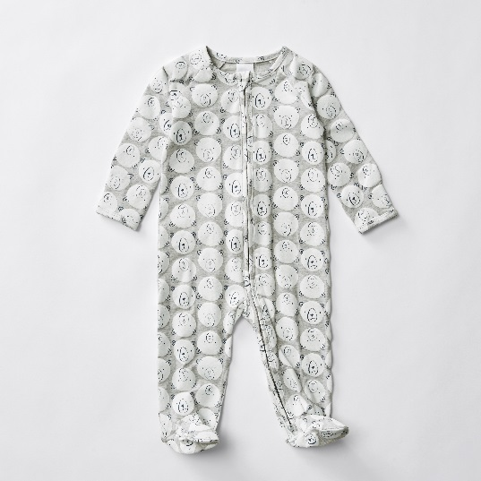

PR 60852717 - BEAR WHITE COVERALL
60852816 - Newborn
60852823 - 0-3 months
60852830 - 3-6 months
60852847 - 6-12 months
60852854 - 12-18 months

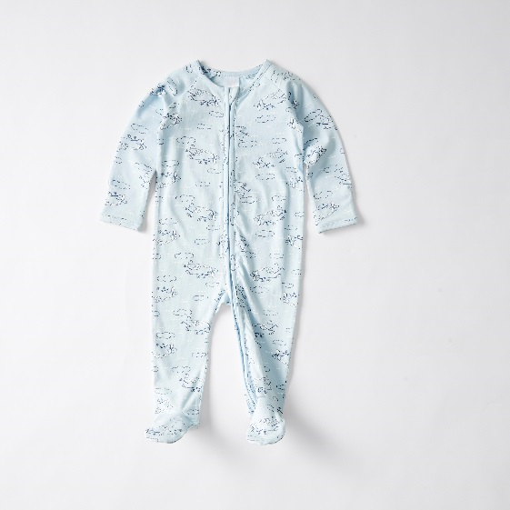

PR 60852748 - PLANE BLUE COVERALL
60853370 - Newborn
60853387 - 0-3 months
60853394 - 3-6 months
60853400 - 6-12 months
60853417 - 12-18 months

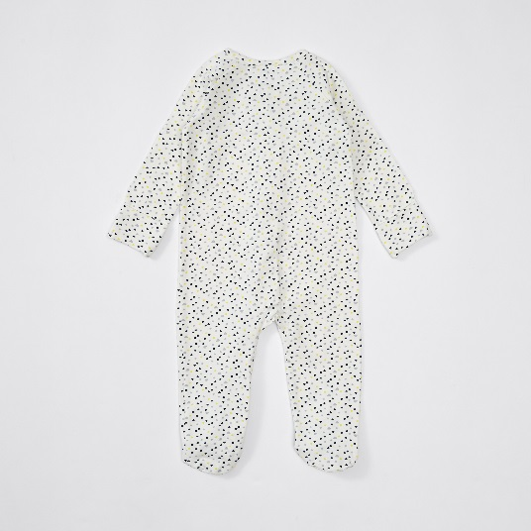

PR 61149359 – HEART WHITE COVERALL
61149724 - Newborn
61149731 - 0-3 months
61149748 - 3-6 months
61149755 - 6-12 months
61149762 - 12-18 months

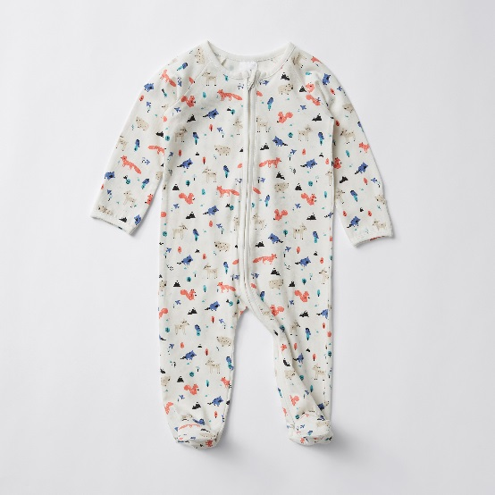

PR 61149311 – FOREST WHITE COVERALL
61149403 - Newborn
61149410 - 0-3 months
61149427 - 3-6 months
61149434 - 6-12 months
61149441 - 12-18 months

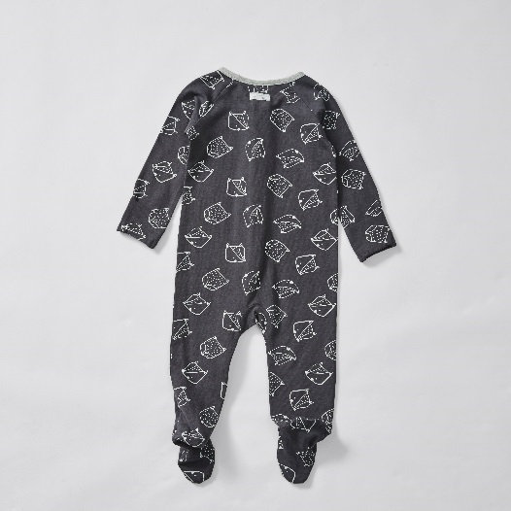

PR 61149328 - FOX GREY COVERALL
61149489 - Newborn
61149496 - 0-3 months
61149502 - 3-6 months
61149519 - 6-12 months
61149526 - 12-18 months

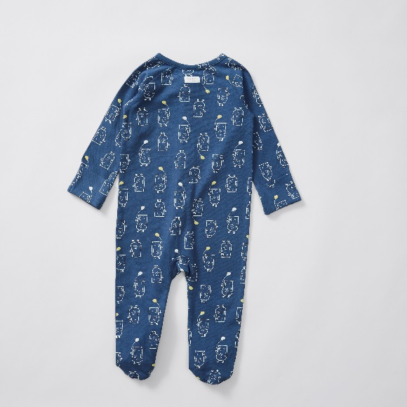

PR 61149366 – BEAR BLUE COVERALL
61149809 - Newborn
61149816 - 0-3 months
61149823 - 3-6 months
61149830 - 6-12 months
61149847 - 12-18 months

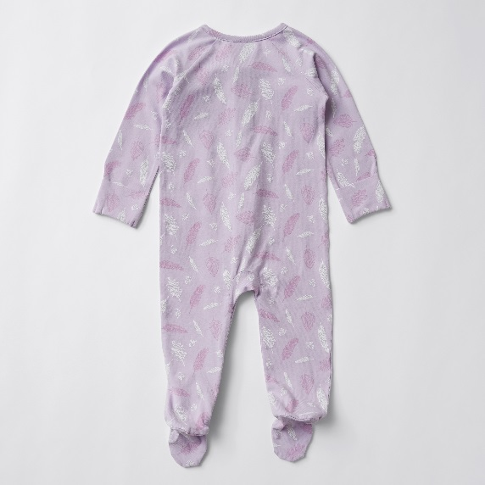

PR 61149373 - FEATHER PURPLE COVERALL
61149649 - Newborn
61149656 - 0-3 months
61149663 - 3-6 months
61149670 - 6-12 months
61149687 - 12-18 months

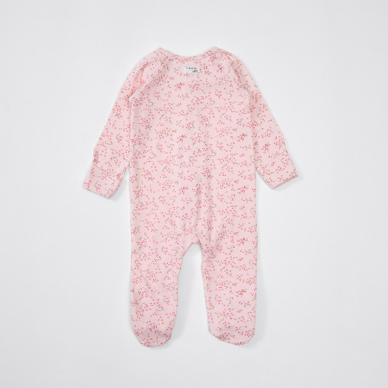

PR 61149342 - FLORAL PINK COVERALL
61149885 - Newborn
61149892 - 0-3 months
61149908 - 3-6 months
61149915 - 6-12 months
61149922 - 12-18 months

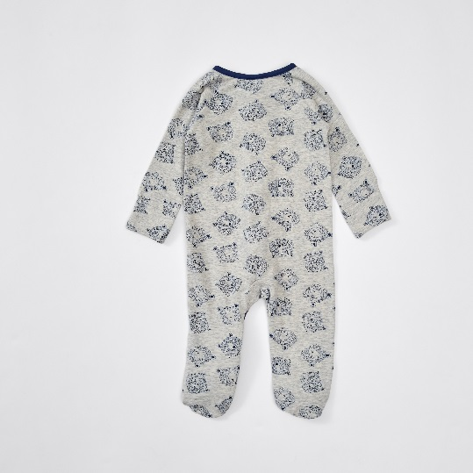

PR 61161665 - BEAR GREY COVERALL
61161696 - Newborn
61161702 - 0-3 months
61161719 - 3-6 months
61161726 - 6-12 months
61161733 - 12-18 months

