

|  |
| --- |
|  |
| **Cosmetic Subscription Services Survey** |
| **Compliance with ingredient labelling requirements of the *Trade Practices (Consumer Product Information Standards) (Cosmetics) Regulations 1991*** |
| **October 2015** |

|  |  |  |
| --- | --- | --- |
|  | | |
|  |  |  |
|  |  |  |
|  |  |  |
|  |  |  |
|  |  |  |

Contents

**Cosmetic Subscription Services Survey** 0

1. Background 2

2. Potential hazards 2

3. Regulations and standards 2

3.1. Australian regulation 2

3.2. International regulations 3

USA 3

EU 3

4. Survey aim and methodology 3

5. Results 3

5.1. Other issues 5

6. Conclusion 5

1. Background

The Australian Competition and Consumer Commission (ACCC) plays an important role in consumer product safety. The ACCC administers national product safety regulations under the *Competition and Consumer Act 2010* (CCA) and monitors the safety of general consumer products. This includes educating suppliers and consumers about regulations, emerging issues, and the safe use of products to minimise the risk of injuries.

The ACCC Infocentre received a consumer complaint about cosmetics subscription services for supplying cosmetics without providing ingredient lists as required in *Trade Practices (Consumer Product Information Standards) (Cosmetics) Regulations 1991* (the Mandatory Standard). A web search provided further evidence that cosmetics subscription services were supplying unlabelled products.

Cosmetic subscription services are an online business model that charges subscribers a monthly fee to regularly receive a box of different cosmetics. The consumer does not usually know what cosmetics they will receive each month. Cosmetic products supplied in these subscriptions may be small promotional samples or full sized products designed for retail. Deliveries may also contain related products such as hair and make-up tools, vouchers for entertainment or services, food and other consumer goods (eg candles, stationery, jewellery, textiles). The business model is growing in popularity overseas and in Australia, and some deliver internationally. Previous ACCC surveillance of cosmetics has not covered cosmetic subscription services.

1. Potential hazards

Labelling of ingredients on cosmetics is important because it helps consumers identify and avoid ingredients that they may be allergic or sensitive to, or otherwise concerned about. Consumers who suffer an adverse reaction from a cosmetic are also able to quickly check the ingredients list to identify the possible causes and seek appropriate treatment.

Cosmetics are frequently used products which account for a significant number of the injury reports received by the ACCC. Injuries include skin irritation, infections, bacterial conjunctivitis, folliculitis, corneal ulcers and anaphylaxis.

1. Regulations and standards
   1. Australian regulation

The Mandatory Standard requires cosmetic products to be labelled with a list of ingredients on the product or product container. The ingredients must be provided in English and listed in descending order by volume or mass.

The Mandatory Standard also requires the ingredient list to be prominently shown and clearly legible. 'Prominent' means that the ingredients list should ‘stand out’ on the product so that consumers can easily find the list on the product or container. 'Clearly legible' means that a person with normal vision can read the whole ingredients list on the product or container without error, strain or difficulty. Together these elements ensure that the information is effectively communicated to consumers.

These are mandatory requirements, so they must be prioritised over other label design criteria such as cost, practicality or visual aesthetics. Products with packaging devices that potentially hide an ingredient list from plain view (like peel away or clam shell labels) may not comply unless there are clear directions that ensure the ingredients list is prominent and clearly legible to consumers. If the size, shape or nature of the product does not allow for this, the ingredients may be provided in another way to ensure consumers are informed. However, if it is possible to display the ingredients on the product or container, this is not an available option. Exceptions to these requirements apply to therapeutic goods, free samples or testers.

In addition to the Mandatory Standard, cosmetic products must meet the requirements of the *Cosmetics Standard 2007* under the *Industrial Chemicals (Notification and Assessment) Act 1989.* Ingredients must be registered on the Australian Inventory of Chemical Substances and must comply with any applicable requirements in the Standard for the Uniform Scheduling of Medicines and Poisons (the Poisons Standard).

* 1. International regulations

### USA

The United States require cosmetics to be labelled with ingredients under the Fair Packaging and Labelling Act. The ingredients must be declared in descending order of predominance and there are specific requirements for the prominence and legibility of the text. Products used at professional establishments or samples distributed free of charge are excluded from these requirements.

### EU

The European Union requires cosmetic products to be labelled with list of ingredients in descending order of weight in indelible, easily legible and visible lettering. If it is impossible for practical reasons to label the product with the ingredients, they must be provided in an enclosed or attached leaflet, label, tag, tape or card. For some products where this is not possible it is acceptable to provide a notice in immediate proximity to the container in which the cosmetic product is exposed for sale. Free samples are not excluded from these requirements.

1. Survey aim and methodology

The ACCC subscribed to the available Australian cosmetic subscription services to assess their compliance with the Mandatory Standard.

The businesses offering the service were identified by searching the internet for them directly and through websites that list, review, rate or compare the different brands. For example see the following website: <http://australiansubscriptionboxes.blogspot.com.au/p/currently-available-boxes.html>

Eight subscriptions from five different Australian businesses were chosen for the survey. These businesses represent most of the market for cosmetic subscription services in Australia.

Subscriptions were delivered monthly or quarterly, and several deliveries from each brand were received. This allowed time to observe non-compliance, contact each business, establish compliance and observe corrective actions.

1. Results

In the first month of the survey, each subscription service supplied cosmetics without ingredient lists or with ingredient lists that were not prominent or legible.

Throughout the survey 197 individual products from over 100 different brands and manufacturers were supplied in 27 deliveries. 38 cosmetic products were supplied with no ingredient list at all (19%), and 6 cosmetic products were supplied with ingredient lists that were not prominent or legible (3%). The rates of non-compliant products for each subscription service are presented in Table 1 below.

**Table 1** Number of non-compliant cosmetics out of the total number of products supplied in each delivery

|  |  |  |  |  |  |  |
| --- | --- | --- | --- | --- | --- | --- |
| Brand | April | May | June | July | August | September |
| Bellabox | 2/6 | 5/6 | 1/6 | 0/6 | 0/6 |  |
| Bellabox - Baby | 2/12 | 4/9 | 2/11 | 0/10 |  |  |
| The Parcel by Girlfriend* | 3/8 |  |  | 1/7 |  |  |
| The Parcel by Marie Claire* |  |  | 0/10 |  |  | 0/7 |
| Lust Have It! | 1/7 | 4/8 | 1/5 | 0/6 |  |  |
| Lust Have It! – Ecobox* |  |  | 4/8 |  |  |  |
| Violet Box | 3/7 | 3/6 | 2/5 | 0/6 |  |  |
| Her Fashion Box | 2/7 | 2/8 | 2/7 | 0/5 | 0/8 |  |

*Quarterly subscription services

Note: The Parcel by Girlfriend and Violet Box were discontinued.

After receiving the first delivery we wrote to each business to provide our assessment of their deliveries and to bring each business into compliance with the Mandatory Standard.

In the first month of the survey, each business was requested to provide the ingredients and their concentrations for each unlabelled cosmetic product as part of a formulation safety audit. Suppliers were reminded of the requirements of the *Industrial Chemicals Notification and Assessment Act* and the Poisons Standard and with the information provided, we confirmed that the products only contained ingredients permitted for use in Australia.

We requested a response detailing how they plan to become compliant and in response, each subscription service committed to emailing their customers with the ingredient lists for the unlabelled cosmetics that they had already supplied. Examples of the corrective emails sent to subscribers are provided at **Attachment A**. These corrections were made for each non-compliant product that we observed throughout the survey.

Each business committed to compliance with the Mandatory Standard in the future and agreed to provide ingredients for each product that they supply. We held discussions with the subscription services and provided advice about how they could achieve compliance. Each subscription service agreed to only distribute labelled products or to provide a supplementary card inside the delivery which lists the ingredients for each product. These changes required cosmetic subscription services to update their procedures and improve coordination with their suppliers. Examples of these cards are provided at **Attachment B**.

At the beginning of the survey some suppliers were unaware of their obligation to comply with the Mandatory Standard. Some of the cosmetic products they supplied without ingredient lists were small units that may not be supplied through conventional retail. In discussions with the businesses, some considered these products to be free samples, and therefore exempt from ingredient labelling requirements. Under the Mandatory Standard free samples are exempt, however, as retailers the cosmetic subscription services charge their customers for the supply of these products. This obligation to provide ingredient lists applies whether or not the retailer received the products free of charge from the manufacturer.

Businesses were also reminded about other obligations under the *Competition and Consumer Act 2010*. Firstly, the subscription services were reminded of mandatory reporting requirements which apply to all businesses in the supply chain for consumer products. They are required to report death, serious injury or illness of any person that they become aware of; and that someone believes was caused by the use of a consumer good which they supply or provide a related service for. A supplier is required to submit the report within two days of becoming aware of a reportable incident.

Secondly, many cosmetic products supplied throughout this survey featured premium and credence claims. Businesses were reminded to take care when making these claims and to ensure that they can be substantiated.

Finally, the businesses were reminded about consumer guarantees relating to the supply of products and services, particularly with regard to delivery of parcels, responding to customer enquiries and processing cancellation requests within a reasonable timeframe.

* 1. Other issues

One subscription service supplied unlabelled sunglasses that did not meet the requirements of the *Consumer Protection Notice No. 13 of 2003 — Consumer product safety standard: Sunglasses and fashion spectacles*. Sunglasses must be labelled with the level of protection from ultra violet radiation (if any) that they provide. The business acted to correct the non-compliance by contacting the recipients of the sunglasses to notify them of the standard that the product met.

Additional products supplied in the deliveries included food products that did not meet the labelling requirements of the Australia New Zealand Food Standards Code and one cosmetic product claiming to contain part of a plant listed in the Convention on International Trade in Endangered Species of Wild Fauna and Flora (CITES). These matters were referred to the relevant authorities for consideration.

1. Conclusion

At the beginning of this survey non-compliance with the requirements of the Mandatory Standard was a significant problem across the sector, as all eight Australian cosmetic subscription services surveyed supplied boxes with one or more cosmetics without adequate ingredient lists.

As a result of the ACCC intervention, the surveyed businesses now understand the requirements of the Mandatory Standard and gave commitments to meet their obligations to comply. All surveyed businesses supplied at least one compliant delivery by the conclusion of the survey.

The impact of this survey extended well beyond the cosmetic subscription services surveyed to over 100 cosmetic brand owners and distributors that they source products from. Subscription services will advise their upstream suppliers to provide complaint products, which will further foster compliance with the Mandatory Standard.

The ACCC will continue to monitor the sector to ensure ongoing compliance with the Mandatory Standard.

**Attachment A**

1. Lust Have It! corrective email

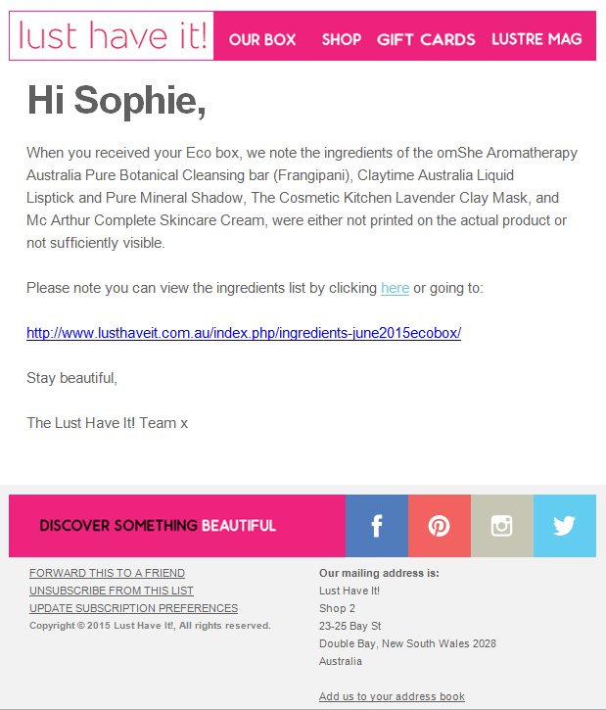

1. Bellabox corrective email

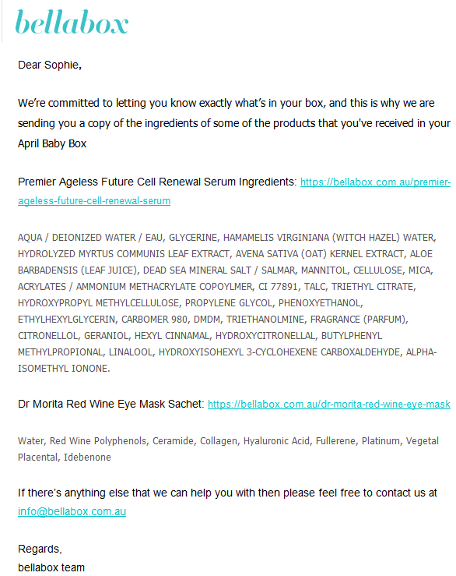

1. The Parcel corrective email

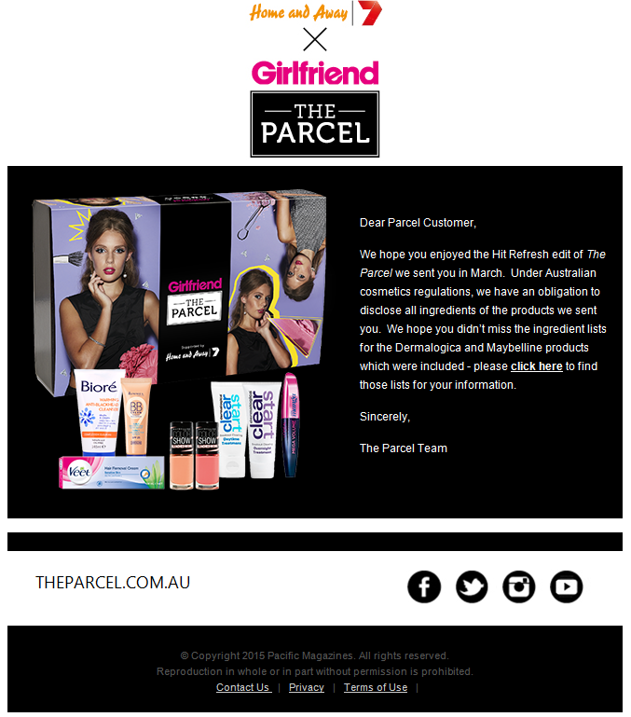

1. Violet Box

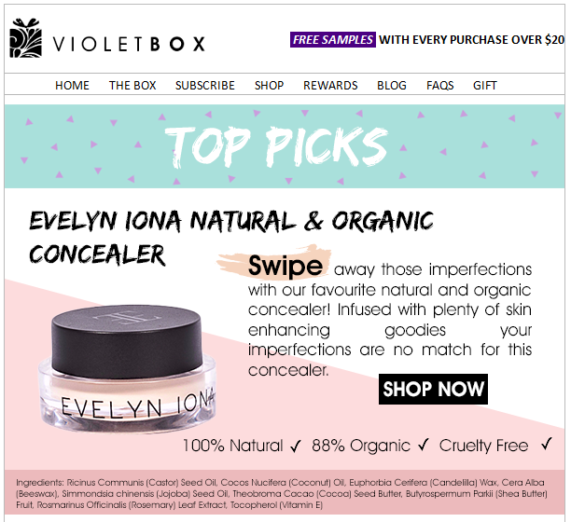

1. Her Fashion Box

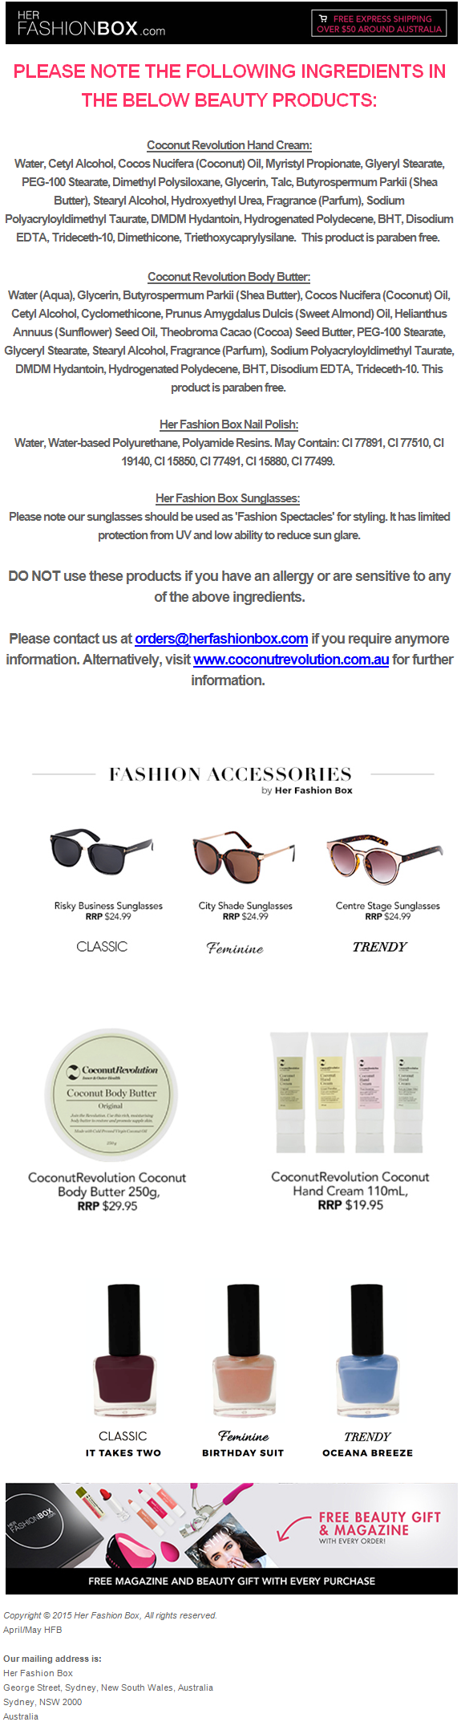

**Attachment B**

1. Bellabox – sample ingredient card to be delivered with boxes.



1. The Parcel by Marie Claire – supplementary card with ingredient lists

