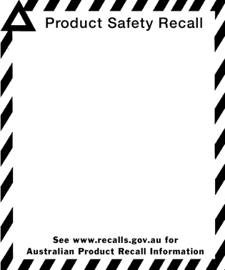

**BLINDS AND TRACKS**

**Retailer**: Spotlight Pty Ltd

**Hazard:** Looped cords, chains or devices on window coverings can cause a strangulation hazard to children

**Brands:** Caprice Options; Windowshade; Funtastic; Dekora Windoware; Wilsons Escape Home

**Product name**: CAPRICE: Blockout Holland Blind; Licensed Roller Blinds (Cars, Princess & Thomas); Day/Night Roller Blind; Blair Roller Blind; Sunshadow Roller Blind; Manhattan Cord Drawn Track; Acacia Rollup Blind; Shanghai Flatstick Rollup Blind; Matchstick Rollup Blind; FUNTASTIC: Licensed Panel Blinds (Dorothy Ballerina, Spiderman Crawling, Bratz & Wiggles); WINDOWEAR: Home Series Cord Drawn Track; WINDOWSHADE: Inca, Kenya & Sierra Roller Blinds; Cully Roller Blind; WILSONS: Escape Home Roller Blind.

**Issues:** **Generic warning label not repeated on instructions** *(note: the products themselves contained warning labels, however one warning label was not repeated in the instructions on how to install the coverings);*

**Instructions do not explain how to install the safety device** where a safety device has been supplied with the products (*note: this does not apply to all of the products listed and only affects the Inca, Kenya & Sierra Roller Blinds and CullyRoller Blind*).

Products sold in Spotlight stores in Australia

***What should you do if you have purchased one of these products?***

Please contact the Spotlight store where you purchased the corded window covering products and request a copy of the revised instructions or obtain the revised instructions online at [www.spotlight.com.au](http://www.spotlight.com.au).

***Contact for further information: 1300 305 405 (Spotlight)***

***Contact for further information: 1300 305 405 (Spotlight)***