**FSANZ Recall:** FSANZ2012/35

**Date:** 4/07/2012



Coles Lite Sour Cream

300ml plastic tub

Use by 02/08/12

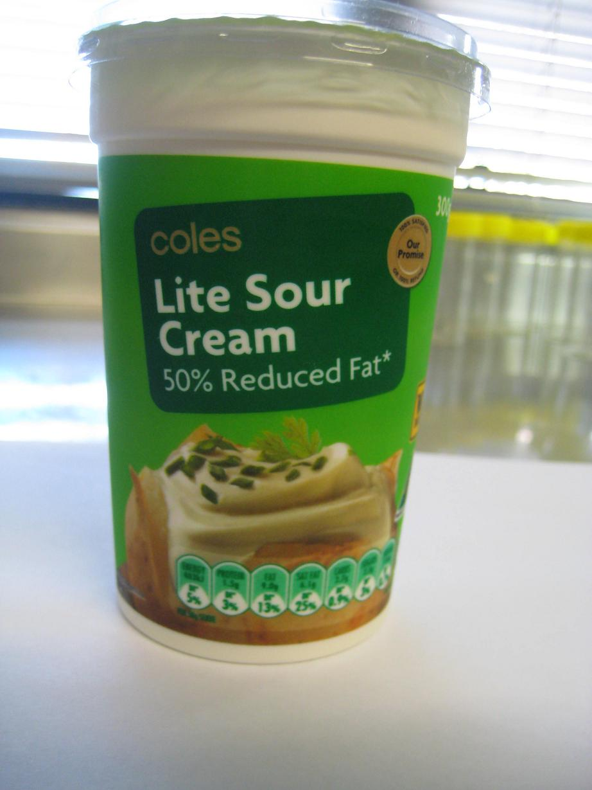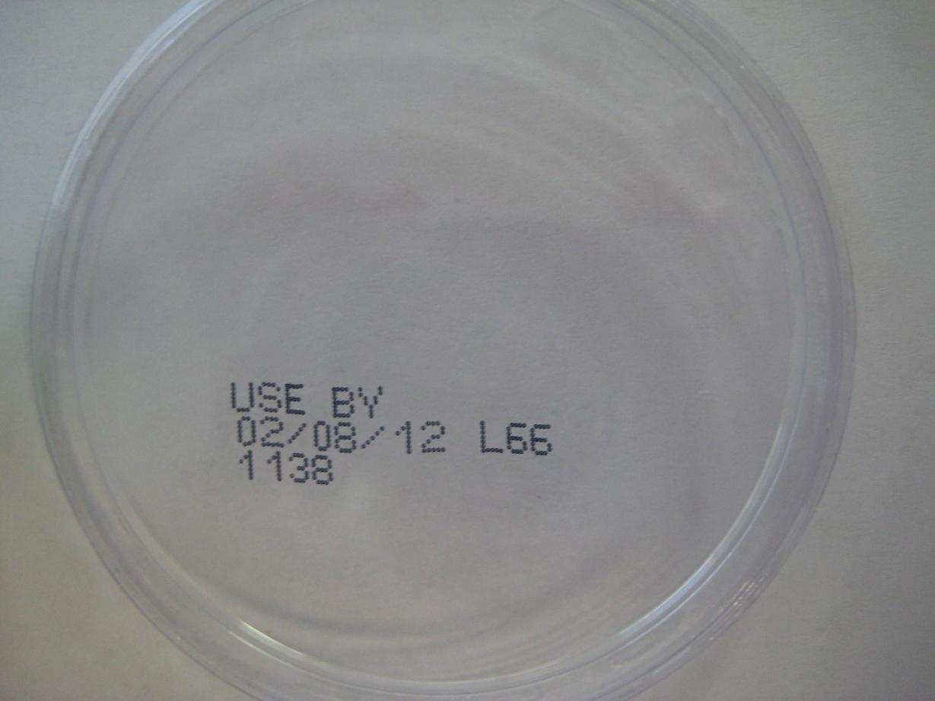

The recalled product has been available for sale in Coles Supermarkets in WA only.

Coles Supermarkets Australia Pty Ltd is conducting a recall of the above product. This recall applies to the above product size and use-by date sold in Western Australia only. No other Coles Sour Cream products are affected by this recall.

Problem: The recall is due to the presence of microbial (E.coli) contamination.

Food Safety Hazard: Food products contaminated with E.coli may cause illness if consumed.

What to do: Any consumers concerned about their health should seek medical advice.

Customers should return the product to the place of purchase for a full cash refund. We apologise for any inconvenience.

For further information please call:

Coles Customer Care

1800 061 562

# FOOD RECALL