ELECTRICAL
SAFETY RECALL

“Three-Sixty” BRAND - Modn-4 and Modn-3 Ceiling Fan.

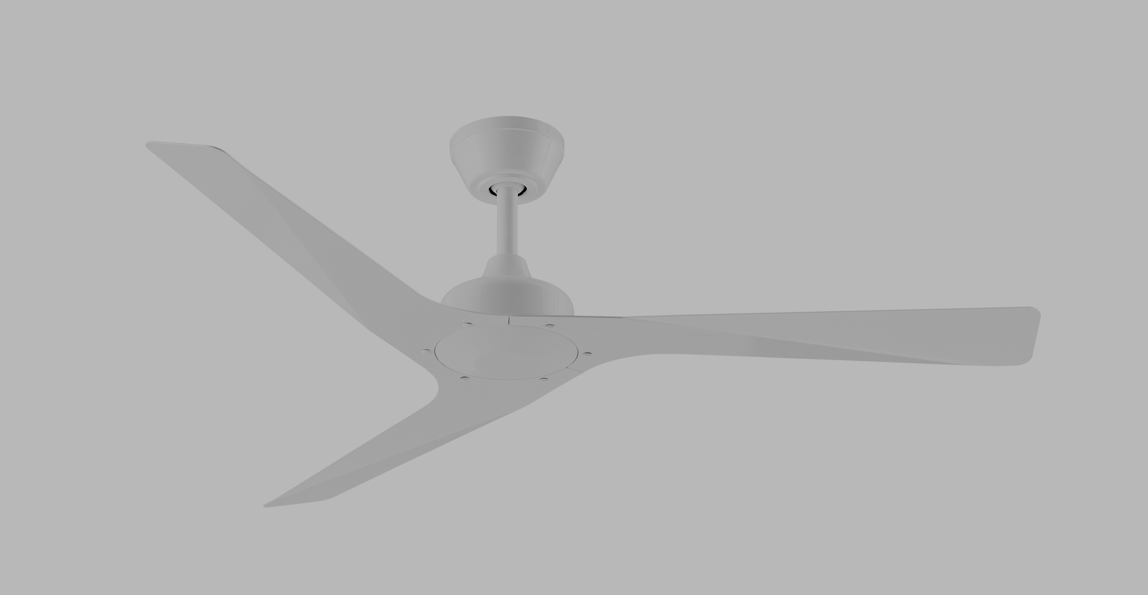
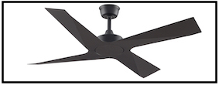

Affected product was sold to electrical retailers and direct to customers between 16th November 2015 and 19th May 2017 (inclusive) and can be identified by
Model # FP6722AU and FP6730AU.
Fans included in the recall are black or white four blade version and white only for the three blade version.

Defect: Conductive parts of the fan may not be effectively earthed, as the motor cover was not manufactured to specifications. In some instances the earth connection from the motor housing does not continue to the motor shaft.

Hazard: A potential electric shock could occur if a live wire were to come into contact with exposed unearthed metal parts.

What to do:
Electrical retailers
1. Check your stock for affected product (by Model numbers)
2. Review sales and installations that may have used affected products.
3. Where affected products have been identified, remove from sale and contact Crestwind. If a product is already installed and cannot be returned, then contact us for further details about rectification requirements.
Consumers
If consumers have had a Three Sixty Modn-3 and Modn-4 installed at their home or premises from 16th November 2015 contact Crestwind or MyFan on 1300 469 326 for further instructions.
For further information
Please direct all calls and any queries concerning this recall to

CRESTWIND or MyFan

Email: info@crestwind.com.au or info@myfan.com.au Phone: 1300 469 326

See www.recalls.gov.au for Australian product recall information

