

**Coles Beetroot Dip**

**200g, USE BY 09 JAN 17**

[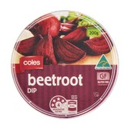](https://shop.coles.com.au/a/a-national/product/coles-dip-beetroot)

The recalled product has been available for sale in

Coles and Bi-Lo Supermarkets throughout Queensland and Coles Supermarkets throughout northern New South Wales. and through Coles Online.

**Problem:** The recall is due the presence of an undeclared allergen - sesame.

**Food Safety Hazard:**

Any consumers who have a sesame allergy or intolerance may have a reaction if the product is consumed.

**What to do:**

Consumers who have a sesame allergy or intolerance should not consume this product.

Customers should return the products to their nearest Coles or Bi-Lo Supermarket for a full refund. Coles apologises for any inconvenience caused.

**Contact details:** Customers seeking further information should contact Coles Customer Care on 1800 061 562.

**FOOD RECALL**

**See www.foodstandards.gov.au/recalls**

**for Australian food recall information**