

CocoLuscious Certified Organic Products:

Coconut Milk Ice Dream Peppermint Choc Chip 500ml  
Coconut Milk Ice Dream Vanilla Choc Chip 500ml Dessert Sauce Chocolate Fudge Sauce 150g Coconut Milk Chocolate 50g

Best Before - All dates

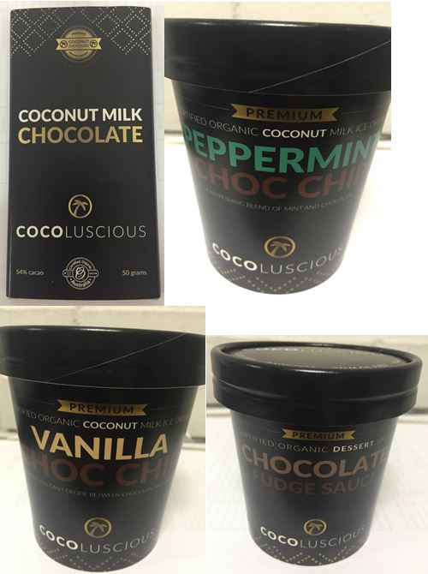

CocoLuscious is conducting a recall of the above products. The products have been available for sale at IGA, independent stores, Chocoholics and restaurants in NSW, ACT, QLD, VIC, SA, WA.

Problem: The recall is due to the presence of an undeclared allergen (milk).

Food safety hazard: Any consumers who have a milk allergy or intolerance may have a reaction if the product is consumed.

What to do: Consumers who have a milk allergy or intolerance should not consume this product and should return the products to the place of purchase for a full refund.

For further information please contact:

CocoLuscious

07 5593 7298

www.cocoluscious.com.au

**See www.foodstandards.gov.au/recalls**

**for Australian food recall information**

**FOOD RECALL**

**See www.foodstandards.gov.au/recalls**

**for Australian food recall information**