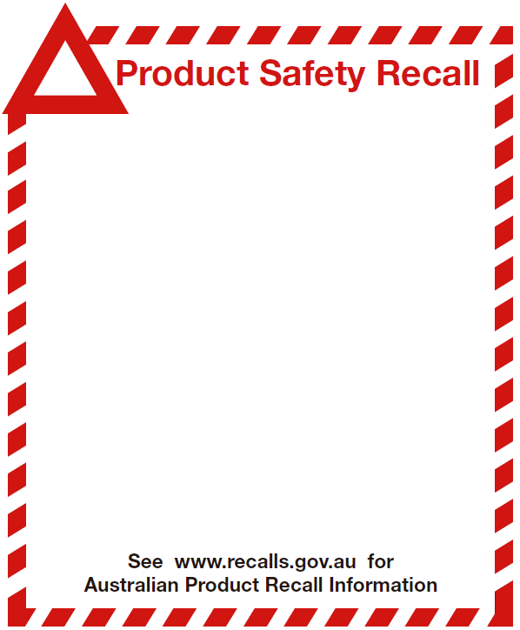

Noosa Bear
From Soft Cuddles, Elka Australia
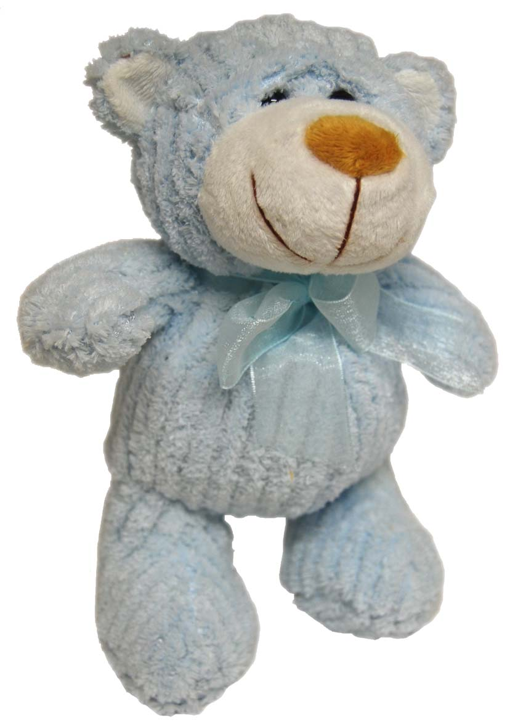

Defect: The tail of the bear may be poorly attached and come away resulting in small parts.

Hazard: If the tail comes away from the toy, it could pose a choking hazard to small children.

What to do: Return the toy to Elka Australia PO Box 111, Milperra, NSW 2214 for a FULL REFUND, including postage. Alternately, contact us on (02) 9774 3777 or sales@elka.com.au for help in returning the product.

