PRODUCT SAFETY WARNING AND RECALL NOTICE
ANNEXURE “D”
GEMWIDE INTERNATIONAL PTY LTD and its director, MR XING ZHANG, have acknowledged to the Director of Consumer Affairs Victoria (“the Director”) that GEMWIDE INTERNATIONAL PTY LTD contravened the product safety provision (sections 33) of the Fair Trading Act 1999 (Vic) (“the Act”), by supplying to the public the toys identified in this Notice, contrary to the Fair Trading Children’s Toys Safety Standard Regulations and the Fair Trading Safety Standards for Lead and Certain Elements in Children’s Toys Regulations. MR XING ZHANG has also acknowledged to the Director that he contravened the same provision of the Act by being involved with GEMWIDE INTERNATIONAL PTY LTD in the supply of the toys identified in this Notice.
Any person who bought the toy or baby products shown in this Notice is asked to return them to a GEMWIDE INTERNATIONAL PTY LTD store for a FULL REFUND (or to safely dispose of the product).
UNSAFE TOY PRODUCTS
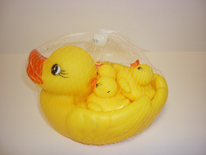 | ⧫ DUCK BATH SET  Description: Children’s rubber squeeze toy bath set, comprising 1 mother duck and 3 baby ducks.  Safety Issue: Small parts can easily break away from the toy and present a choking hazard to young children. | 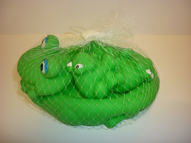 | ⧫ FROG BATH SET  Description: Children’s rubber squeeze toy bath set, comprising 1 mother frog and 3 baby frogs.  Safety Issue: Small parts can easily break away from the toy and present a choking hazard to young children.
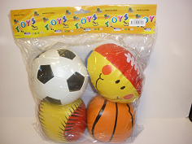 | ⧫ “TOYS”, PLUSH TOY BALLS  Description: 4 stitched plush toy balls, comprising a soccer ball, rugby ball, basketball ball, and baseball. Made in China.  Safety Issue: Children’s toys having accessible materials with a lead migration level greater than that permitted under AS/NZS Standards. | 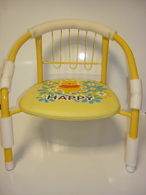 | ⧫ “HAPPY” CHAIR  Description: Metal-framed children’s chair with plastic padded seat.  Safety Issue: Children’s toys having accessible materials with a lead migration level greater than that permitted under AS/NZS Standards.
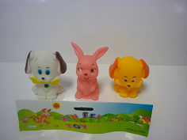 | ⧫ “XIN FEI TOY” ANIMAL BATH SET  Description: Children’s rubber squeeze toy bath set, comprising 2 puppies with a bone, and 1 bunny rabbit. Made in China.  Safety Issue: Small parts can easily break away from the toy and present a choking hazard to young children. | 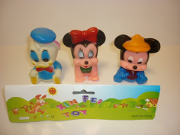 | ⧫ “XIN FEI TOY” DISNEY BATH SET  Description: Children’s rubber squeeze toy bath set, comprising baby Donald Duck, Minnie Mouse, and Mickey Mouse. Made in China.  Safety Issue: Small parts can easily break away from the toy and present a choking hazard to young children.
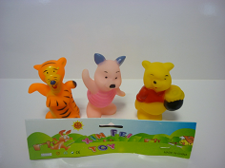 | ⧫ “XIN FEI TOY” WINNIE THE POOH BATH SET  Description: Children’s rubber squeeze toy bath set, comprising Winnie the Pooh, Tigger, and Piglet. Made in China.  Safety Issue: Small parts can easily break away from the toy and present a choking hazard to young children. | 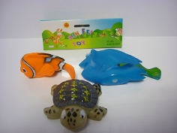 | ⧫ ”XIN FEI TOY” FINDING NEMO FISH BATH SET  Description: Children’s rubber squeeze toy bath set, comprising Nemo (orange clownfish), Dory (blue surgeonfish), and Crush (brown loggerhead sea turtle). (Item No. 806).  Safety Issue: Small parts can easily break away from the toy and present a choking hazard to young children.
GEMWIDE INTERNATIONAL PTY LTD LOCATION
14-16 Clifford Street
HUNTINGDALE VICTORIA 3166
Tel: (03) 9548 8148 (Melway Ref 69 K10)
GEMWIDE INTERNATIONAL PTY LTD and MR XING ZHANG have undertaken to the Director, under section 146 of the Act, that GEMWIDE INTERNATIONAL PTY LTD will not supply goods of a class or kind in respect of which there is a product safety standard or ban order until GEMWIDE INTERNATIONAL PTY LTD has implemented a Compliance Program designed to ensure that it does not supply such goods, to publish this Notice, to recall the goods identified above, pay FULL REFUNDS to all persons returning the goods, and to engage a Compliance Professional to review, annually, for 3 years its compliance with product safety standards and ban orders.

