

Peach Coconut Drink240ml

All use by dates up to and including 2015.10.28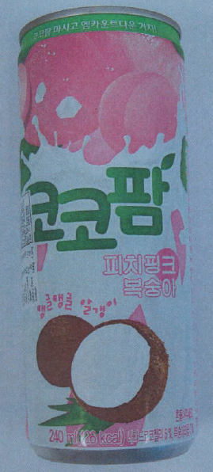

CA National Services Pty Ltd is conducting a recall of the above product. The product has been available for sale at Asian grocery stores in QLD.

Problem: The recall is due to the presence of an undeclared allergen (dairy).

Food safety Hazard: Consumers who have a dairy allergy or intolerance may have a reaction if the product is consumed.

What to do: Consumers who have a dairy allergy or intolerance should not consume this product and should return the product to the place of purchase for full refund.

For further information please contact:

CA National Services Pty Ltd

0410 095 909

**See www.foodstandards.gov.au/recalls**

**for Australian food recall information**

**FOOD RECALL**

**See www.foodstandards.gov.au/recalls**

**for Australian food recall information**