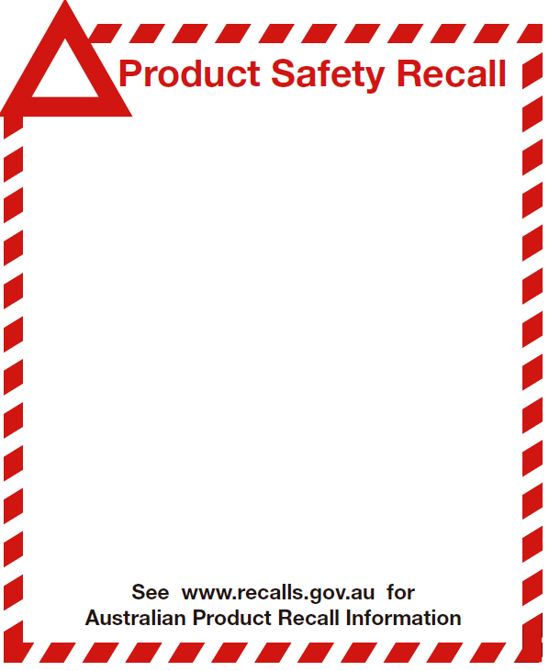

PA0428 – GLOW WHISTLE
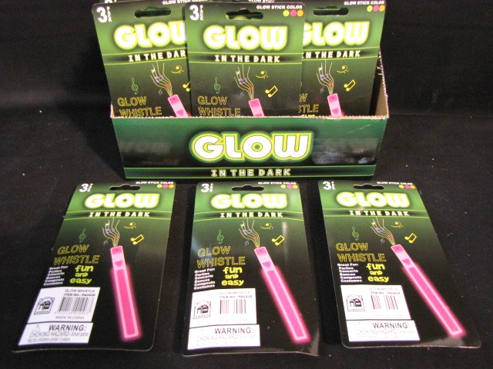

Mayvic (SWEDA) Pty Ltd is undertaking a recall on this product. It has been sold through various retailers nationally during September thru till December 2010.

DEFECT: This product has contains a small inner piece that with great enough suction force may dislodge.

HAZARD: This presents a possible choking hazard if enough sucking force is applied and the piece becomes dislodged whilst inhaling.

WHAT TO DO: Return to the place of purchase for a FULL REFUND

CONTACT DETAILS: Mayvic (SWEDA) Pty Ltd
11-17 Longfield Street LANSVALE NSW 2166
PHONE - 02 97230966 FAX – 02 97231322
www.mayvic.com.au

