

Product Safety Recall

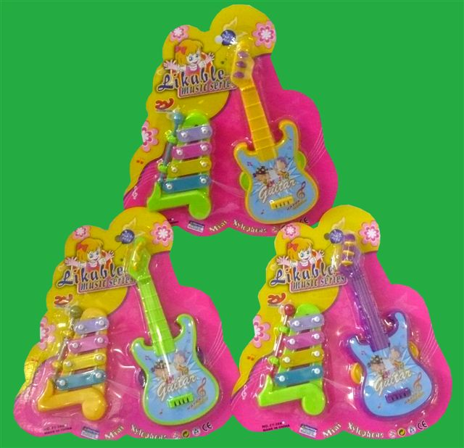
PJ SAS Trading Pty Ltd is conducting a voluntary recall of the Likeable Music Series children’s toy item number 117130.

The Likeable Music Series toy was supplied at this store between August 2010 and November 2010. When tested to the Australian Toy Standard the Likeable Music Series toy released dangerous small parts which are a significant inhalation hazard to young children.

Consumers should cease using this toy immediately and destroy or return to this store to receive a full refund.

For further information please telephone PJ SAS Trading Pty Ltd on telephone number 02 9602 5444

See www.recalls.gov.au for
Australian Product Recall Information

