

**See www.foodstandards.gov.au/recalls**

**for Australian food recall information**

**FOOD RECALL**

**See www.foodstandards.gov.au/recalls**

**for Australian food recall information**

Maree Wilkinson

Vanilla Pancake Mix 250g, Chocolate Cake Mix 580g, Raspberry Cacao Granola 500g

Best Before Dates: 29/4/18, 2/5/18, 14/5/18, 1/6/18, 2/6/18, 4/7/18, 6/7/18, 17/7/18, 20/7/18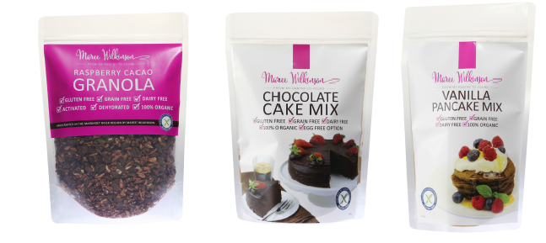

The products have been available for sale at independent grocery stores and health food stores in WA*.*

Problem: The recall is due to the presence of an undeclared allergen (gluten).

Food safety hazard: Consumers who have a gluten allergy or intolerance may have a reaction if the product is consumed.

What to do: Consumers who have a gluten allergy or intolerance should not consume this product and should return the products to the place of purchase for a full refund.

For further information please contact:

Cape Wholefoods

0404 377 900

www.mareewilkinson.com.au