

**FOOD RECALL**

**See www.foodstandards.gov.au/recalls**

**for Australian food recall information**

**See www.foodstandards.gov.au/recalls**

**for Australian food recall information**

|  |  |
| --- | --- |
| Granny Macs Dark Chocolate Coffee Beans | |
| 150 grams | |
| Best Before | 02.06.17 |

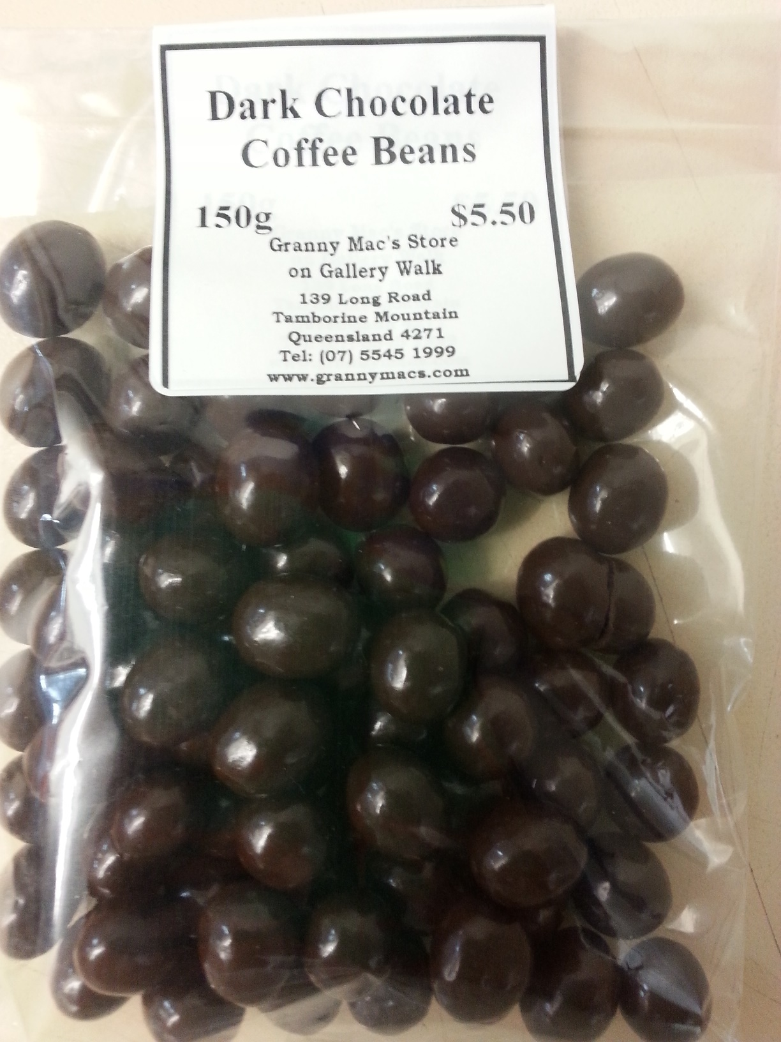

ARC Therapies ATF The ffrench Family Trust T/A Granny MACS is conducting a recall of the above product. The product has been available for sale at the Granny Macs store in QLD*.*

Problem: The recall is due to the presence of an undeclared allergen (peanuts).

Food safety hazard: Any consumers who have a (peanut) allergy or intolerance may have a reaction if the product is consumed.

What to do: Consumers who have a (peanut) allergy or intolerance should not consume this product and should return the product to the place of purchase for a full refund.

For further information please contact:

Granny Macs

07 5545 1999

http://www.grannymacs.com