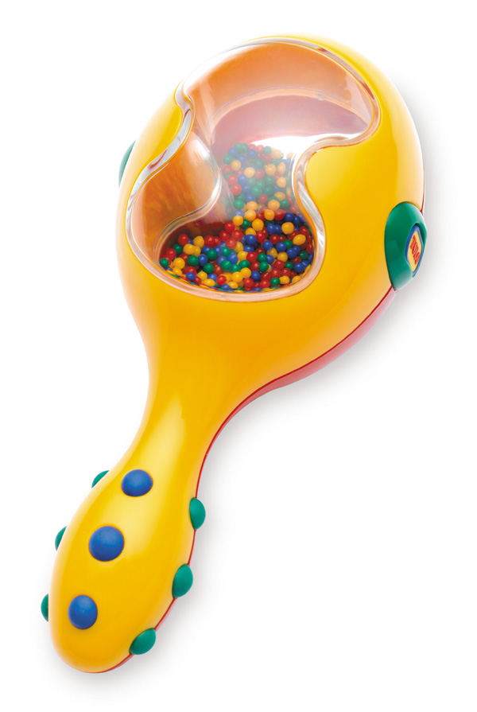

Tolo Maraca Rattle (item code 89655)
Sold nationally at specialist gift and toy stores

This was on sale between February 2010 and December 2010

Defect: The product is being recalled due to failing to comply with the mandatory requirements for rattles and teethers.

Hazard: Rattles and teethers that are of a shape and size that can enter a child's throat may present a choking hazard.

What to do: Return to the place of purchase for a full refund or contact Bright Spark Enterprises Pty Ltd directly to organise a replacement item of equal value.

Contact Details: contact Bright Spark Enterprises Pty Ltd on 07-3205-5757 or email sales@brightsparktoys.com.au

