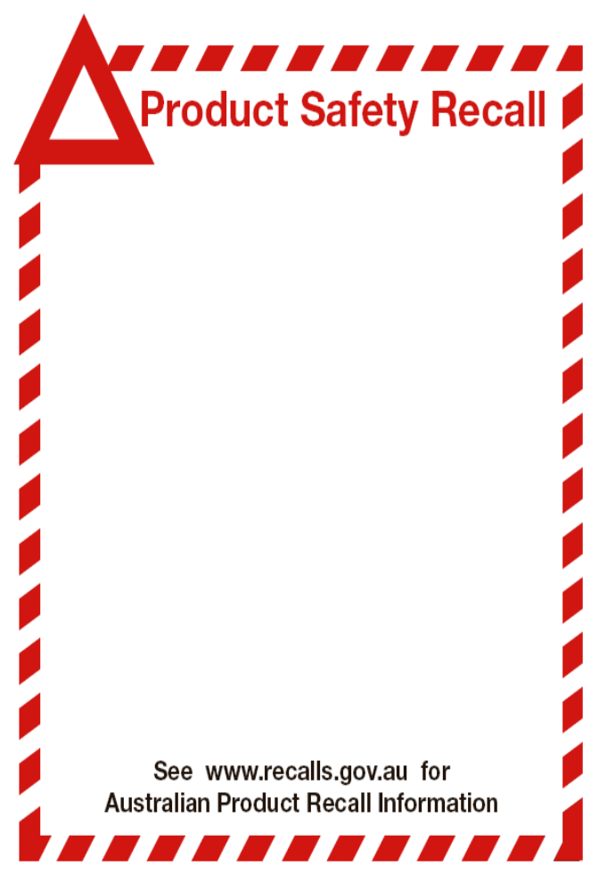
Product Information

Product Part Number and Description
JT414 Orcon 1400kg Trolley Jack Batch #: 18584-08.2012

Defect:
The jack failed to meet the serviceability requirements of section 5.5 and 6.7x

Effected Products:
JT414 batch #:18584-082012 supplied from December 2012

What Should Consumers do;

Consumer Actions:
Stop using your jack immediately and return to the place of purchase, for an exchange or full refund.

Further Information:

Supplier Information:
Haigh Australia Pty Ltd
64 Argyle Parade
Darra, Queensland, 4076
Ph: (07) 3375 3933

Supplier Web Site:
www.haigh.com.au

Suppler Contact:
Les Somers


