

**See www.foodstandards.gov.au/recalls**

**for Australian food recall information**

**FOOD RECALL**

**See www.foodstandards.gov.au/recalls**

**for Australian food recall information**

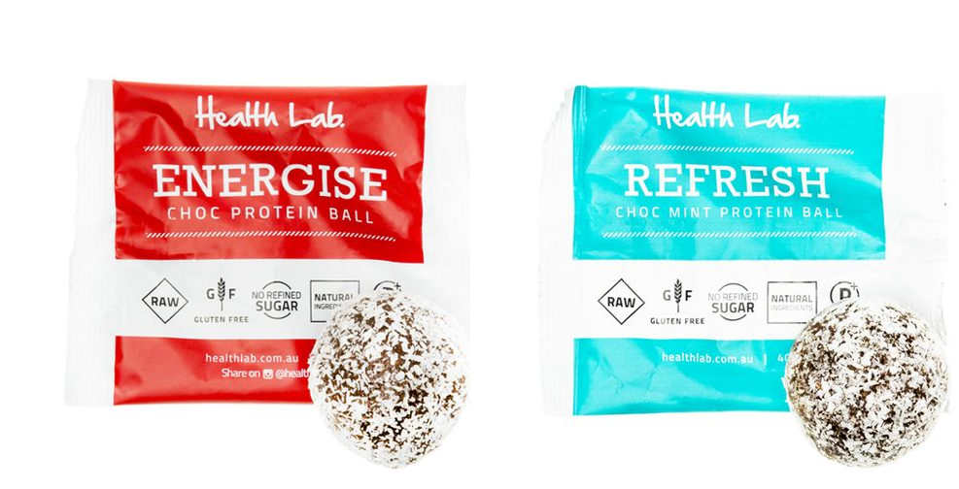

**Energise Choc Protein Balls and Refresh Choc Mint Protein Balls, 40g**

**Use By Energise balls: 09/03/2017, 23/03/2017, 04/04/2017Use By Refresh balls: 13/03/2017, 05/04/2017, 17/04/2017**

Health Lab is conducting a recall of the above products. The products have been available for sale at Caltex in NSW, QLD and Vic and On The Go stores in SA.

**Problem:** The recall is due to the presence of an undeclared allergen (cashew nut).

**Food safety hazard:** Consumers who have a cashew nut allergy or intolerance may have a reaction if the product is consumed.

**What to do:** Consumers who have a cashew nut allergy or intolerance should not consume this product and should return the products to the place of purchase for a full refund.

For further information please contact:

**Health Lab**

**(03) 9999 8535**

**www.healthlab.com.au**