

**Picky Picky Peanuts Tangy Mexican Salsa**

**(80g, best before JUL2017, batch number F3666-HNFN)**

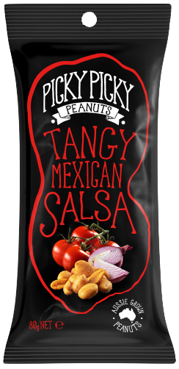

The recalled product has been available for sale in

IGA & other Independent Grocery & Convenience Stores, Fruit Markets, BWS & other Liquor outlets, Woolworths Fuel, Taste South Burnett, Clovely Estate City Cellar Door, Dusty Hill Vineyard, Super Butcher.

**Problem:** The recall is due to the presence of an undeclared dairy allergen.

**Food Safety Hazard:** Any consumers who have a dairy allergy or intolerance may have a reaction if the product is consumed.

**What to do:** Consumers who have a dairy allergy or intolerance should not consume this product.

Customers should return the product to the place of purchase for a full cash refund. If purchased online, customers should destroy the product and will receive a full refund. We apologise for any inconvenience.

**Contact details:** For further information contact the Peanut Company of Australia, 07 4162 6311

**FOOD RECALL**

**See www.foodstandards.gov.au/recalls**

**for Australian food recall information**