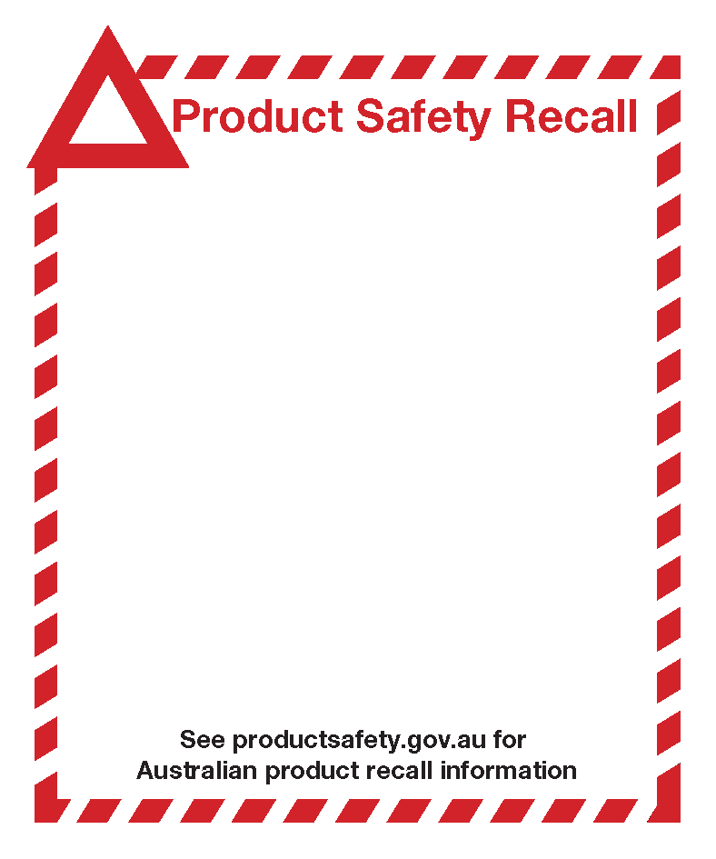

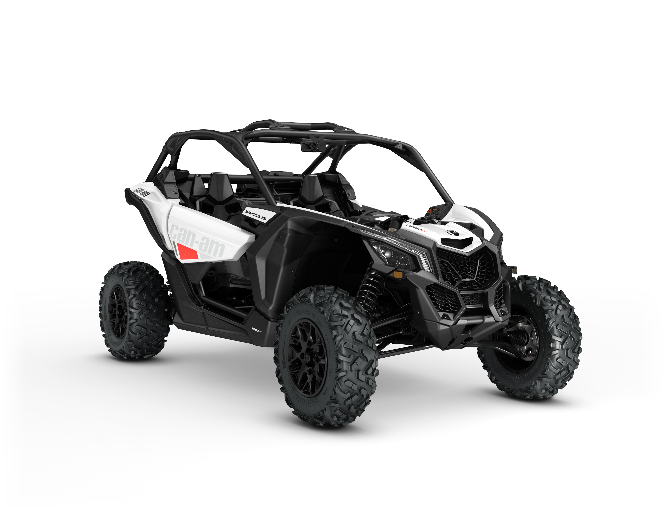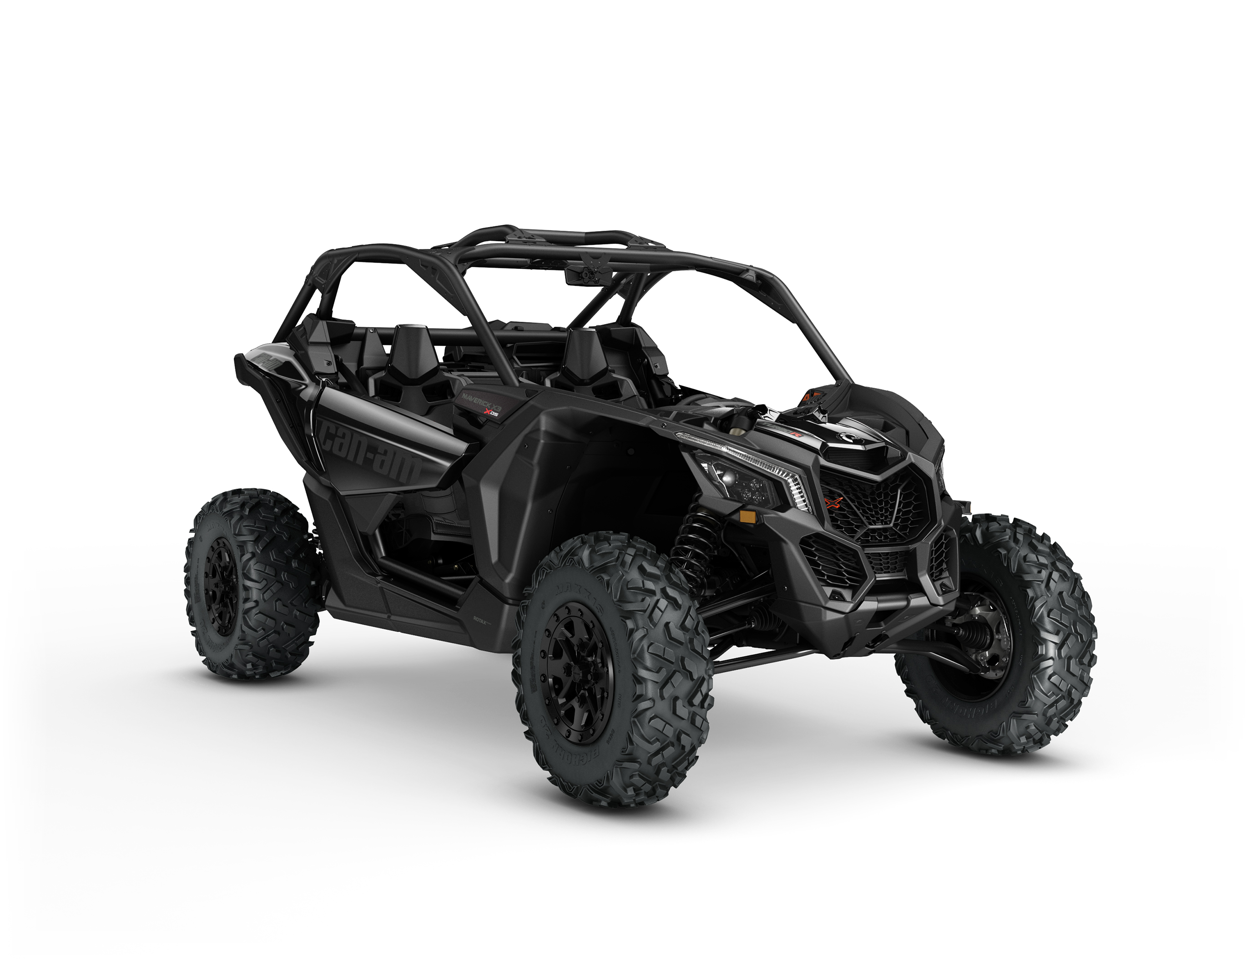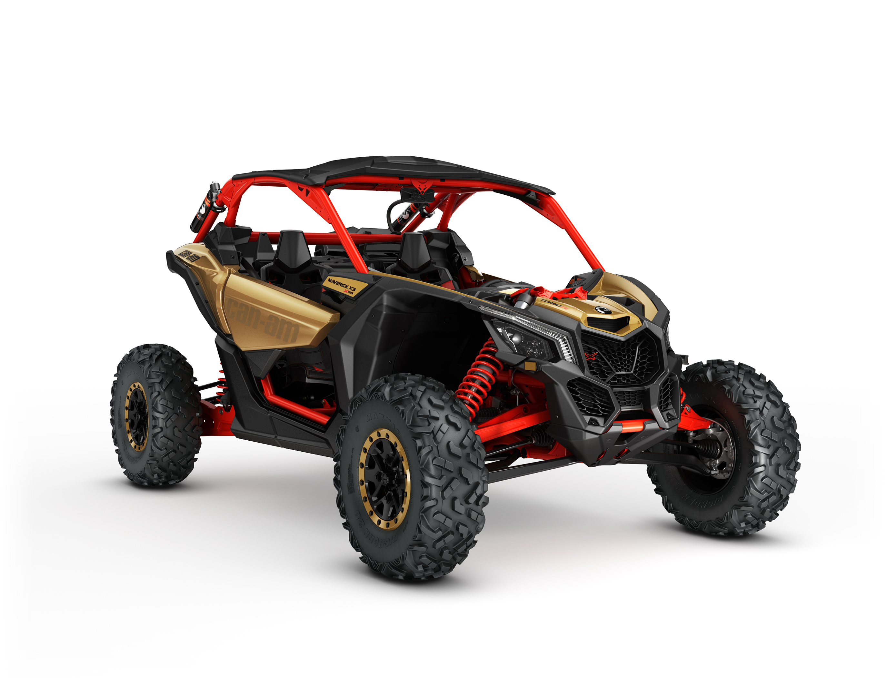

Certain serial numbers of model year 2017 Can-Am Maverick X3.

Defect The steering rack and pinion assembly may have been manufactured by the supplier with an improper amount of grease.

Hazard In some circumstances, the improper amount of grease on the steering rack and pinion assembly may result in steering lock, potentially causing a serious injury to the rider.

What to do Consumers with warranty registration will be contacted by direct mail. Consumers should contact their authorised BRP Can-Am side-by-side dealer to arrange for the vehicle repair.

BRP recommends that you avoid driving your vehicle until the repair is performed.

Contact details If you have questions or need assistance, or to find the nearest authorised BRP Can-am side-by side dealer:
• Visit http://au.brp.com/off-road/
• infobrpaustralia@brp.com

