###### Product Safety Recall

##### Hot Topic Glass Bottle 650ml

**Australian Postal Corporation**

**Barcode: 9330921118623**

**Item No: 67794**

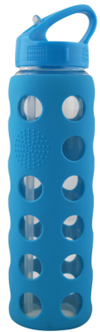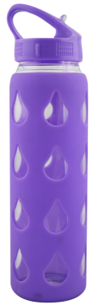

**Defect** Australia Post is recalling the Hot Topic Glass Bottle 650ml (Barcode: 9330921118623) sold at Post Offices nationwide from Monday 16 January to Monday 30 January 2017. The product was advertised in the ‘Get back to business’ catalogue.

**Hazard** The Hot Topic Glass Bottles lid may break off from the rest of the bottle when it is unscrewed, revealing raw glass edges. This may cause injury to consumers.

**What to do** Any customer who has purchased the Hot Topic Glass Bottle from a Post Office or received the bottle as a gift should cease using it immediately and return it to a Post Office for a full refund.

We apologise to our customers for any inconvenience caused.

**Contact details** Please direct all calls and queries concerning this recall to

Australia Post Customer Contact Centre on 13 13 18.

**See** [**www.recalls.gov.au**](http://www.recalls.gov.au) **for Australian Product Recall Information**