

Product Safety Recall

Apple Baby Necessities &
Ai-Non Baby Pacifiers

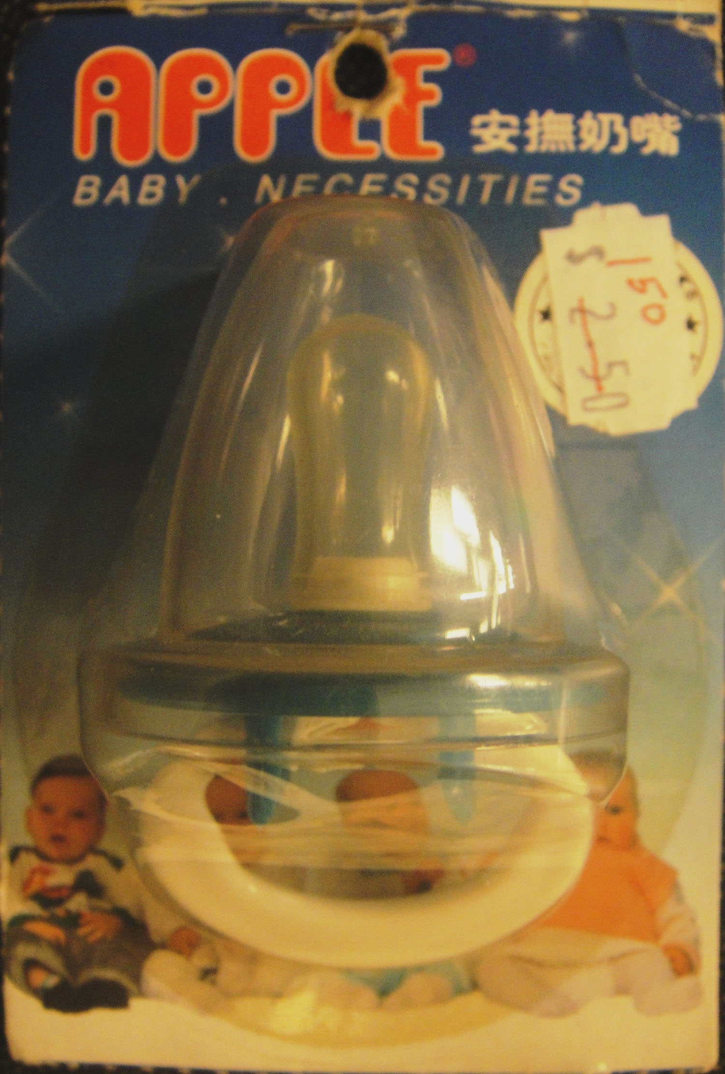

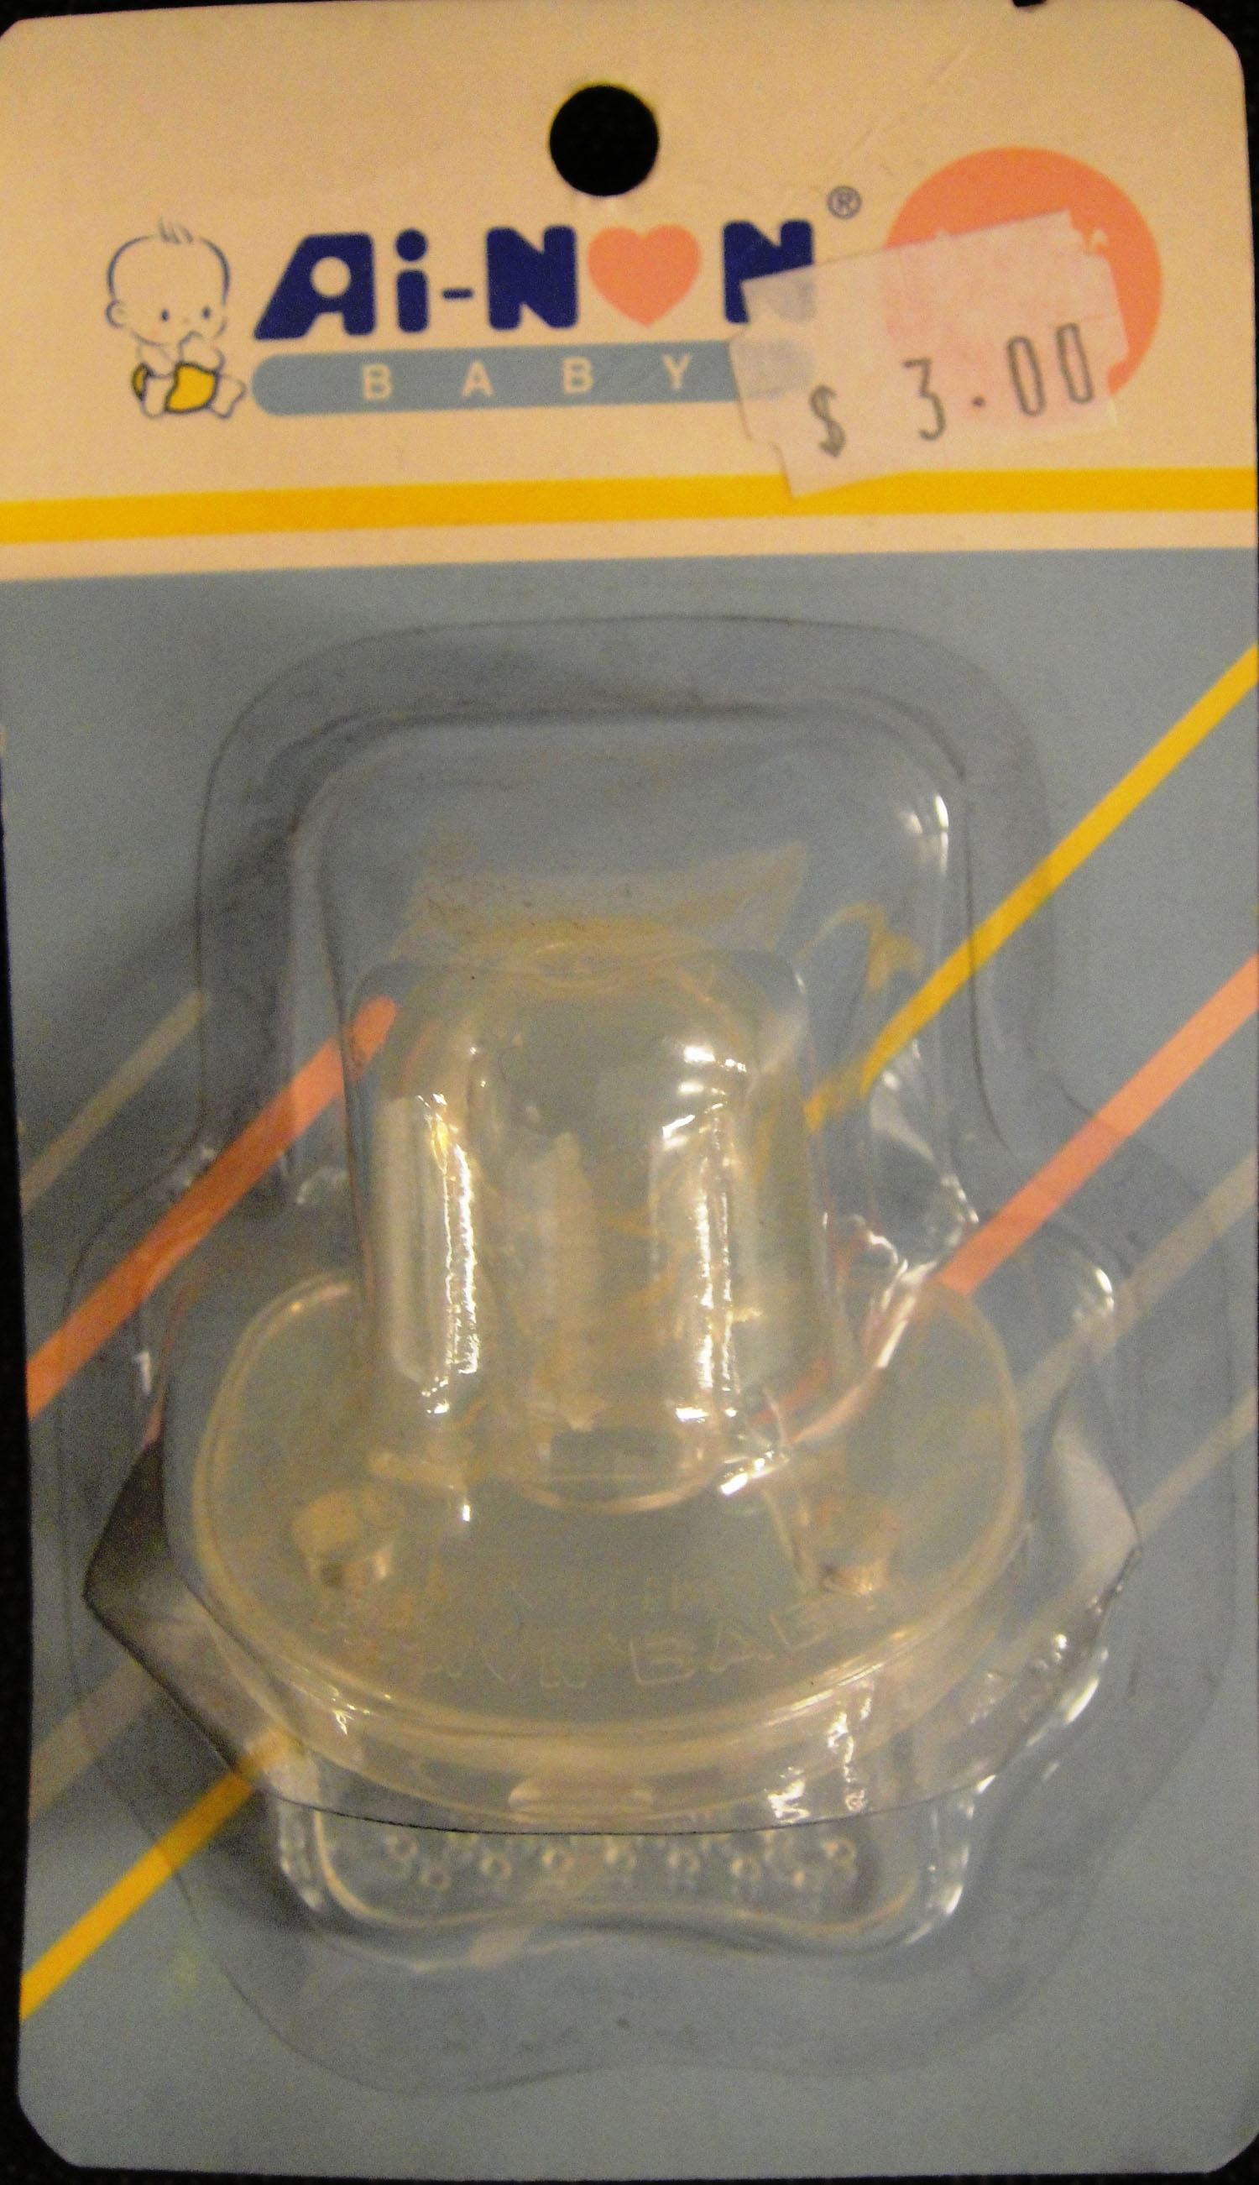
On the advice of the NSW Office of Fair Trading, Yens Clearance Warehouse is conducting a voluntary recall of the Apple Baby Necessaries & Ai-Non Baby Pacifiers. There is a concern that because of its size, the shield and small ventilation holes may block the airways of a young child. In addition the ring on these dummies can detach and create a choking hazard. These dummies were sold at this store between June 2008 and June 2009. Consumers should cease using this dummy immediately and destroy or return to this store to receive a full refund.

PRODUCT RECALL

See www.recalls.gov.au for
Australian Product Recall Information

