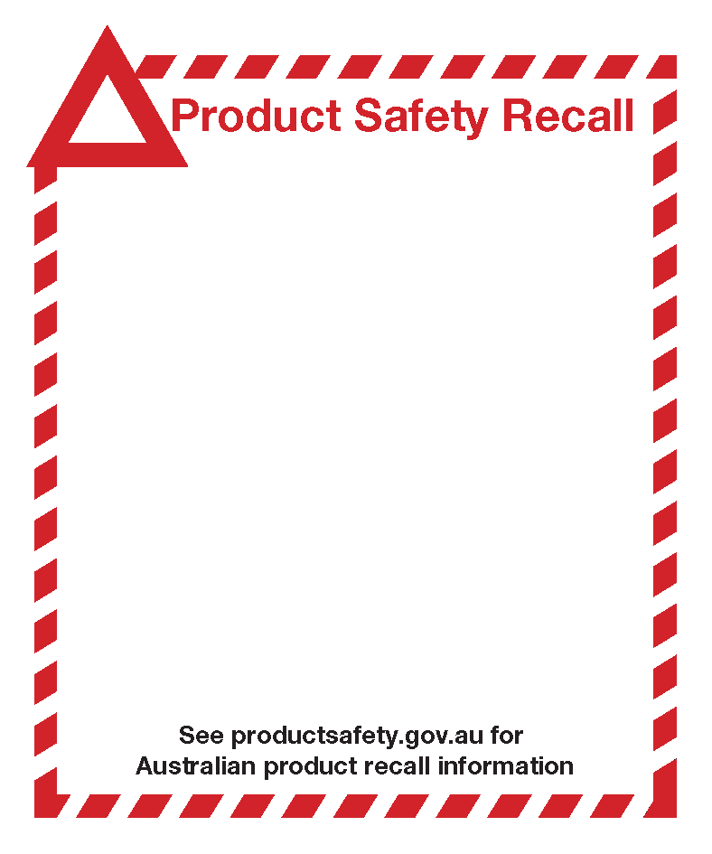

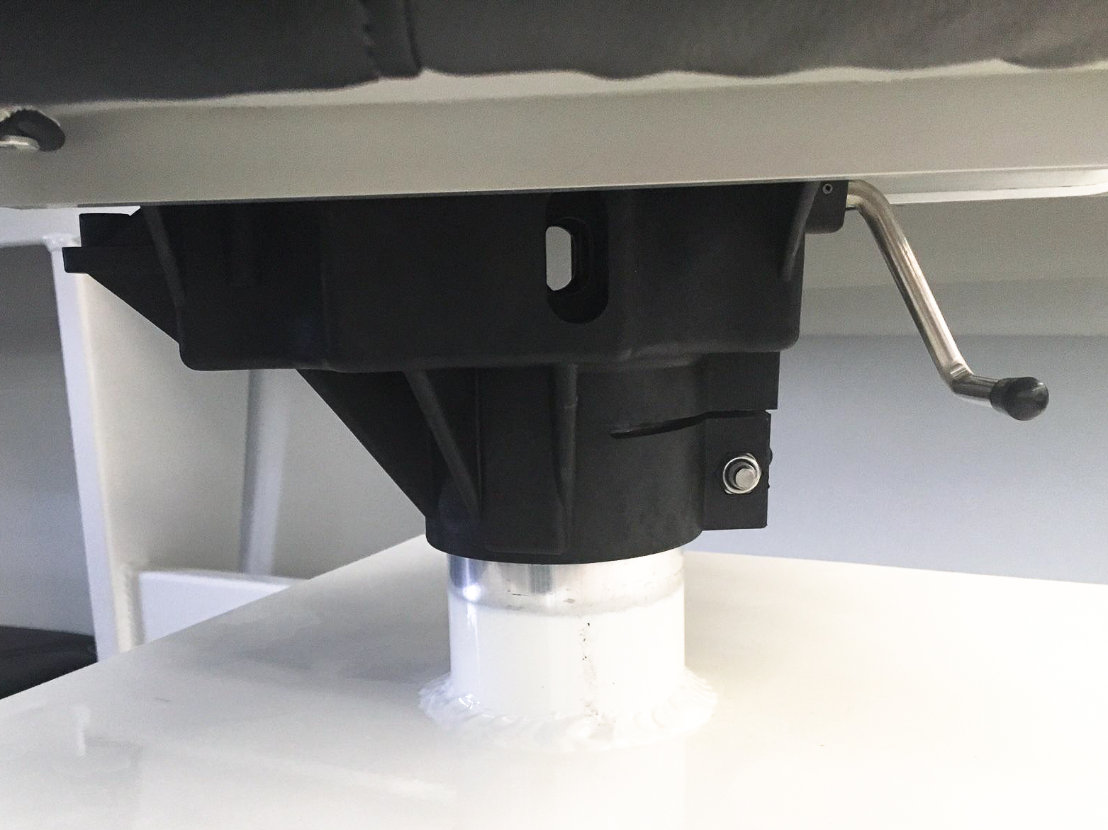

Seat Pivot Black Plastic Slide fitted under Bolster Seats.
(Note: Recall does not apply to non-Bolster Seat installations)

Date of sale: Sold by Bar Crusher Boats and Bar Crusher Boat’s dealers fitted to bolster style seats between March 2014 and November 2016.

Defect: The black plastic pivot / slide mechanism fitted under the bolster style seat that acts as the mounting mechanism to the seat box tube, may crack under very heavy loads and extreme forces.

Hazard: If the pivot / slide mechanism cracks and fails, the seat could detach from the seat box and pose a fall hazard to consumers.

What to do: Inspect the black plastic mechanism for cracks and if any are identified do not use the seat until the pivot is replaced. If you have this style of pivot / slide mechanism fitted under your BOLSTER seats, consumers should contact Bar Crusher boats via the web address below to register for rectification.

Contact Details: Contact Bar Crusher Boats by emailing your contact details with “Safety Recall” as the subject to info@barcrusher.com.au and Bar Crusher will provide advice and guidance to remedy the matter.

Your email will need to provide the following information:

- Your name, mailing address and phone contact.
- Model of boat.
- HIN Number from HIN plate at rear of engine pod.

In addition, you may call Bar Crusher on 03 9792 2999 for advice 11.00am to 4.00pm Monday to Friday however, registration for recall is still requested online.

