
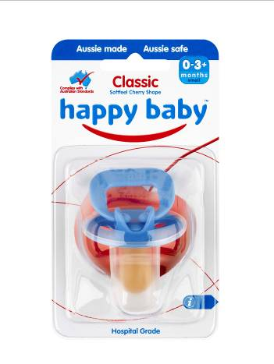
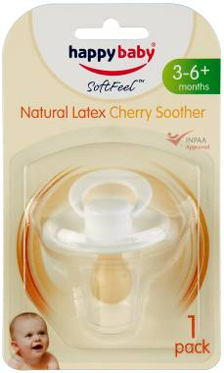
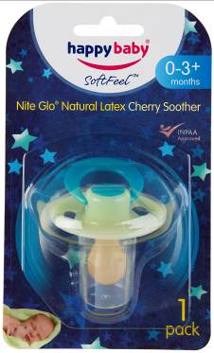
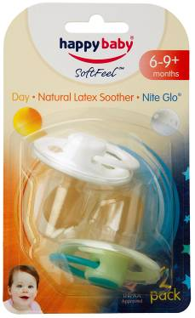
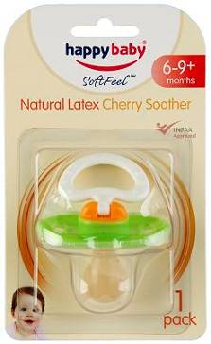

Product Description The affected products are the following latex dummies, whenever purchased (not limited by lot)
Happy Baby® Soft Feel™ Natural Latex Cherry Soother – premature
Happy Baby® Soft Feel™ Natural Latex Cherry Soother – newborn
Happy Baby® Soft Feel™ Natural Latex Cherry Soother – 0-3+ months
Happy Baby® Soft Feel™ Natural Latex Cherry Soother –3-6+ months
Happy Baby® Soft Feel™ Natural Latex Cherry Soother –6-9+ months
Happy Baby® Soft Feel™ Natural Latex Cherry Soother –9-18+ months
Happy Baby® Soft Feel™ Nite Glo® Natural Latex Cherry Soother – 0-3+months
Happy Baby® Soft Feel™ Nite Glo® Natural Latex Cherry Soother– 3-6+ months
Happy Baby® Soft Feel™ Nite Glo® Natural Latex Cherry Soother – 6-9+ months
Happy Baby® Soft Feel™ Nite Glo® Natural Latex Cherry Soother – 9-18+ months
Happy Baby® Soft Feel™ Day/Nite Natural Latex Cherry Soother – 6-9+ months
Happy Baby® Soft Feel™ Day/Nite Natural Latex Cherry Soother – 9-18+ months
Happy Baby® Smilie Soft Feel™ Natural Latex Cherry Soother – 6-9+ months
Happy Baby® Smilie Soft Feel™ Natural Latex Cherry Soother – 9-18+ months
Defect – There may be a risk of the teat separating from the shield
Hazard – Teat separation may present a choking hazard
What to do Customers should immediately cease using these products and return them to Sanbrook Brands for a full refund, replacement silicone soother or Happy Baby® online voucher.
Contact Details Please return the product to Sanbrook Brands Pty Ltd, Reply Paid 501, Boronia, VIC 3155, with your name and mailing address and it will be replaced with a silicone soother, a full refund or a Happy Baby® online voucher at your option (please specify your option).
For more information, please call freecall 1800 335 917 or email safety@sanbrook.com.au
Sanbrook Brands Pty Ltd 991 Mountain Highway, Boronia, Victoria 3155
See www.recalls.gov.au for
Australian Product Recall Information

