Important Information

PRODUCT SAFETY
RECALL

Watts Clever – Standby Power Controller
Model No: ES-AU1111 & ES-AU1110
Installed 1st May 2012- 7th August 2012

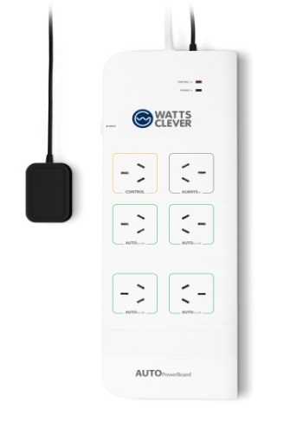
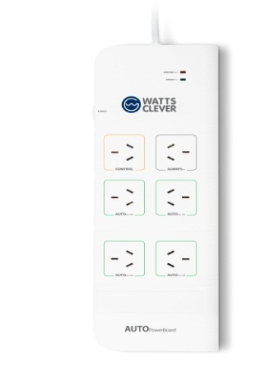
Our records show that your household may have been supplied with a Watts Clever energy saving device.

ES-AU1111 ES-AU1110

Defect: Earthing wire is not connected correctly in the Power board as per Australian Safety Standards.

Hazard: POTENTIAL ELECTRIC SHOCK
If the Power Board is used incorrectly or with faulty appliances, this could result in an electric shock. Only AV Boards with serial numbers beginning with 1111 and IT Boards with serial numbers beginning with 1110 are affected.

What to do: You should immediately UN-PLUG and STOP USING the Power board/s. Please keep the power board/s ready for collection. DO NOT DISPOSE OF THEM. A representative from Watts Clever will visit over the coming months to collect the power board/s.

Contact details: You can contact Watts Clever either at recall@wattsclever.com or call 1300 884 963.

See www.recalls.gov.au for Australian Product Recall Information

