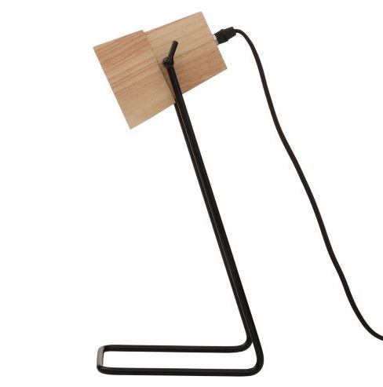

ZOX Table Lamp
MODEL: 23760752

Sold at Freedom stores between October 2016 and June 2017.
DEFECT: A manufacturing fault that allows certain light globes to be fitted that should not be used with this lamp.
HAZARD: The use of certain light globes can lead to overheating of the wooden shade which is a fire hazard.
WHAT TO DO: Please stop using the lamp and return it to your nearest Freedom store for a full refund or exchange for a similar product.
CONTACT DETAILS:
Customer service 1300 135 588 (Mon-Fri 9am- 5.30pm)
Email zoxlamp@freedom.com.au
Website freedom.com.au

