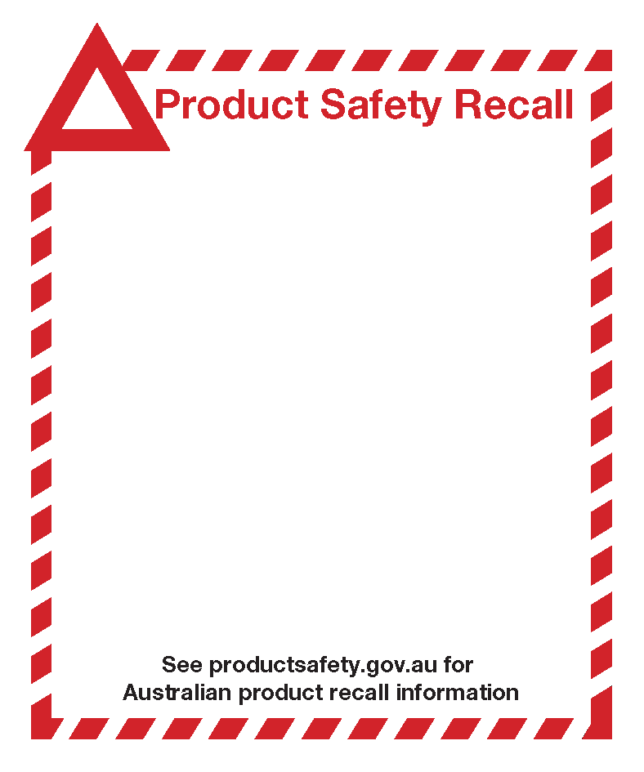
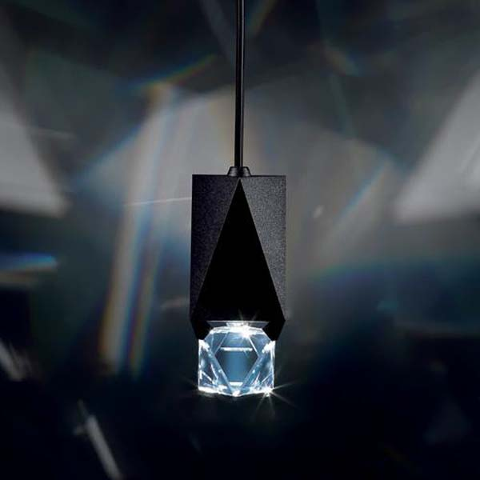
Octa Crystal Pendant light fixtures
With article numbers A9950NR700122 and A9950NR700123
Sold from 2013 - 2015

Defect: The crystal in the light fixture can detach if damaged during shipment.

Hazard: If the crystal in the light fixture detaches and falls, it poses an impact hazard.

What to do: Consumers should prevent people from walking underneath the light fixtures and contact Swarovski at lighting.ap@swarovski.com to schedule a free inspection and repair if required.

